|  |
| --- |
| University of New South Wales |
| Assignment 1 – Part B |
| Refrigeration and Air Conditioning |

|  |
| --- |
| Xinyi Wang  Z5038392 |

Contents

1. Introduction 4

2. Conditioned/Ventilated Space Maps and Thermal Zone Plans 4

2.1 Definition and Comparison of Conditioned and Ventilated Spaces with Examples 4

2.2 Overlay of the Building Floor Plan and Spaces Without conditioning and ventilation 4

2.3 Thermal Zoning and Its Relevant Information in Heat Load Calculations 6

2.4 Floor Plan Overlay of Thermal Zoning 6

3. Ventilated Space Calculations 10

3.1 Ventilation Type of Carpark 10

3.2 Smallest Number of Exhaust Systems 11

3.3 Exhaust Rate for Each Ventilated Space 11

4. CAMEL Heat Load Simulation 11

4.1 Critical Conditions 11

4.2 Building Features 11

4.2.1 Partitions 11

4.2.2 Roof Loads 12

4.2.3 Skylights 12

4.3 Simulation and Report of Heating and Cooling Loads 12

4.3.1 AHU settings 12

4.3.2 AHU Coil Settings 13

4.3.3 Zone and Rooms Descriptions 13

4.3.4 External Walls Settings 16

4.3.5 Partitions Settings 20

4.3.6 Internal Heat Loads Settings 23

5 Validation of Heating and Cooling Load Calculation 24

5.3 Safety Factors and Diversity Factors 24

6 Air Schematics 24

6.1 Purpose of Air Schematics and Information Provided 24

6.2 Air Schematics Construction 24

7 Duct Design 25

7.1 25

7.2 25

7.3 Riser and Its Purpose 25

7.4 Riser Location and Size 25

7.5 Duct Overlay 25

8 Pressure Loss Calculation and Fan Selection 32

8.1 Index Run 32

8.2 Index Run on All Supply and Exhaust Systems 32

8.3 Formula for Pressure Loss of Straight Duct and Duct Fittings 36

8.4 Calculation and Report of Pressure Loss along the Index Run 36

8.5 Three Factors in Fan Selection 36

8.6 Fans Selection 37

9 AHU Selection 40

10 Improvements and Suggestions 42

10.1 Three Building Features with the Most Significant Heat Load and Improvements 42

10.2 Reducing Air Off Temperature and Cooling Coil Capacity 44

10.3 Improvements to Reduce Required Cooling Capacity 44

10.3.1 Adding Thermal Insulation Materials on External Walls 44

10.3.2 Food Court façade 47

10.3.3 Shading on Windows 50

References 52

Appendix 1 53

Appendix 2 Ductulator Result of Duct Sizes 54

Appendix 3 Detailed Duct Design of Ground Floor and First Floor 58

# Introduction

Assignment 1 – Part B is based on Assignment 1 – Part A (hand calculation). In part B, air conditioned spaces and ventilated spaces are identified. Air conditioned area is divided into different thermal zones. Camel software is utilised to simulate and outcome of Camel simulation is compared with hand calculation outcome finished in Assignment 1 – Part A. Air schematics of air conditioning is drawn and ducts are designed. AHU (air handling units) is selected based on air flow rate and power. For ventilated spaces, pressure loss of index run is calculated and its fans are selected. Improvements and suggestions for this shopping mall are made based on Camel simulation outcome.

Assumptions:

1. Food court outlets (room 115-118) are open spaces without separation from outside.
2. Rooms with similar orientations receive similar solar heat gain like MM22 and MM23 on first floor with west and southwest orientations.
3. Amenities and its corridor share the same exhaust system.
4. We assume the opening hours is from 9am from 9pm the same as Westfield in Sydney <https://www.google.com/search?q=google&rct=j#q=westfield+opening+hours>
5. Area of food court on first floor (void) is the same with area of food court on ground floor due to these two spaces are similar to a large extent.
6. All windows on walls are gasketed to avoid infiltration.
7. No partitioning is needed on windows for the sake of cost reduction.
8. Surface densities of materials with similar U-values in Camel wall settings are similar too.
9. Due to structure complexity of roof of 212 and 213, we assume its surface density is
10. 6mm plate glazing has a surface density of because 4mm glass plate has a surface density of . <http://www.saint-gobain-sekurit.com/glossary/glass-properties>
11. U-value of ceiling on ground floor is the same as U-value of first floor’s floor. And U-value of ceiling on first floor is the same as U-value of roof. This assumption will be justified in 4.3.4.
12. The false ceiling space (1.5m air space) is void. This assumption will be justified in 4.3.4.
13. All shop walls facing court yard are regarded as external walls, which keeps the same with Part A.
14. Occupancy of 212 is maximum, i.e., 80 people. And occupancy of 213 is maximum (90) in order to keep the same with the assumption made in Part A for design hour.

# 2. Conditioned/Ventilated Space Maps and Thermal Zone Plans

## 2.1 Definition and Comparison of Conditioned and Ventilated Spaces with Examples

Conditioned spaces are areas where supply air enters with mechanical systems, say HVAC system. Two good examples in case are shop 212 (bookshop/internet cafe) and shop213 (restaurant). While ventilated spaces are areas where supply air enters as a result of pressure difference caused by natural forces. Amenities corridor and garbage room are two instances of ventilated spaces.

## 2.2 Overlay of the Building Floor Plan and Spaces Without conditioning and ventilation

Overlays of first floor, ground floor and carpark are shown in Figure 1, Figure 2 and Figure 3 respectively below. Note: blue colour indicates conditioned spaces, red colour indicates ventilated spaces and green colour indicates neither conditioned nor ventilated spaces. In terms of expenses of air conditioning and low usage, garbage, amenities corridor and carpark are naturally ventilated. Courtyard on first floor is open area and there is no need to consider air conditioning and natural ventilation in this case. While the rest spaces of this shopping mall is air conditioned.

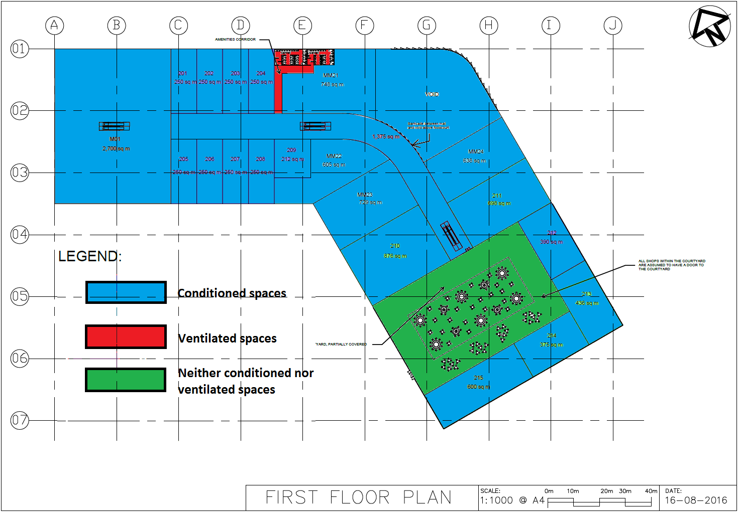

**Figure 1 Overlay of First Floor Plan**

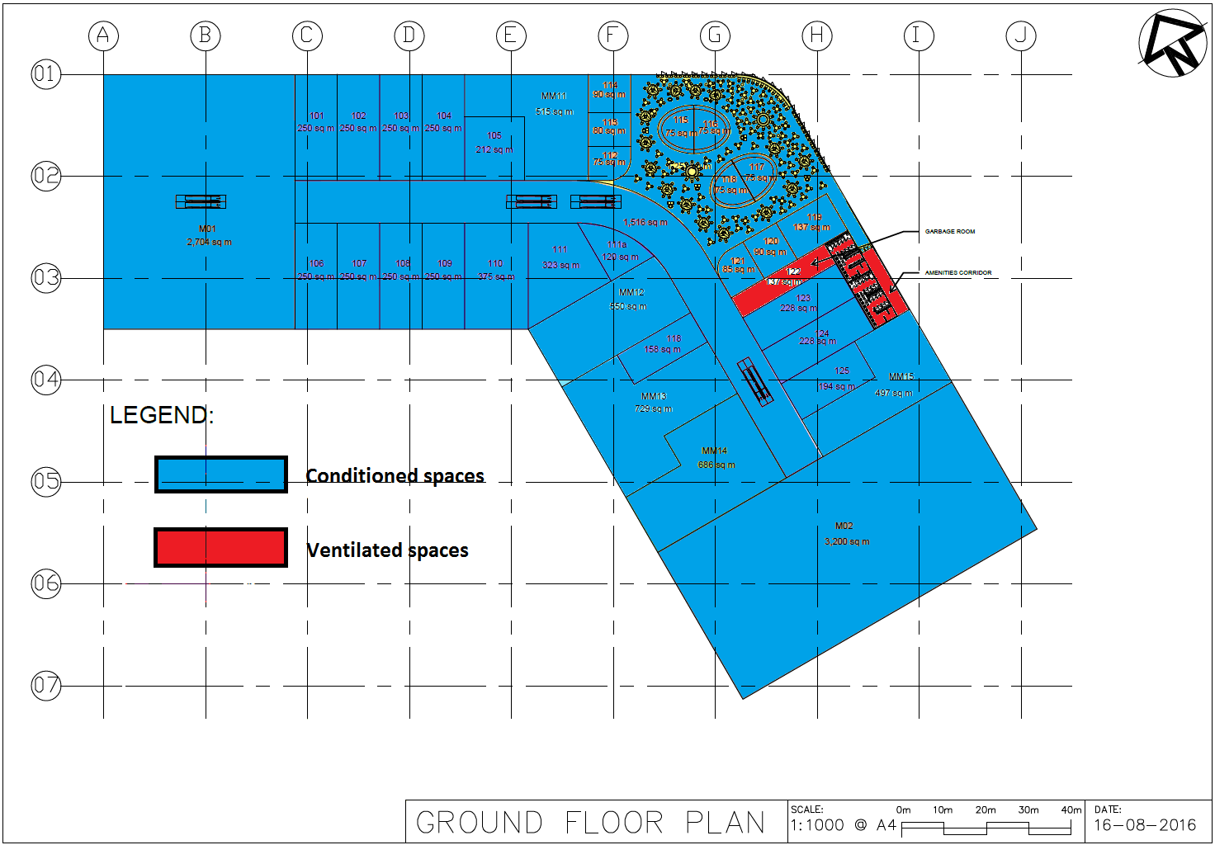

**Figure 2 Overlay of Ground Floor Plan**

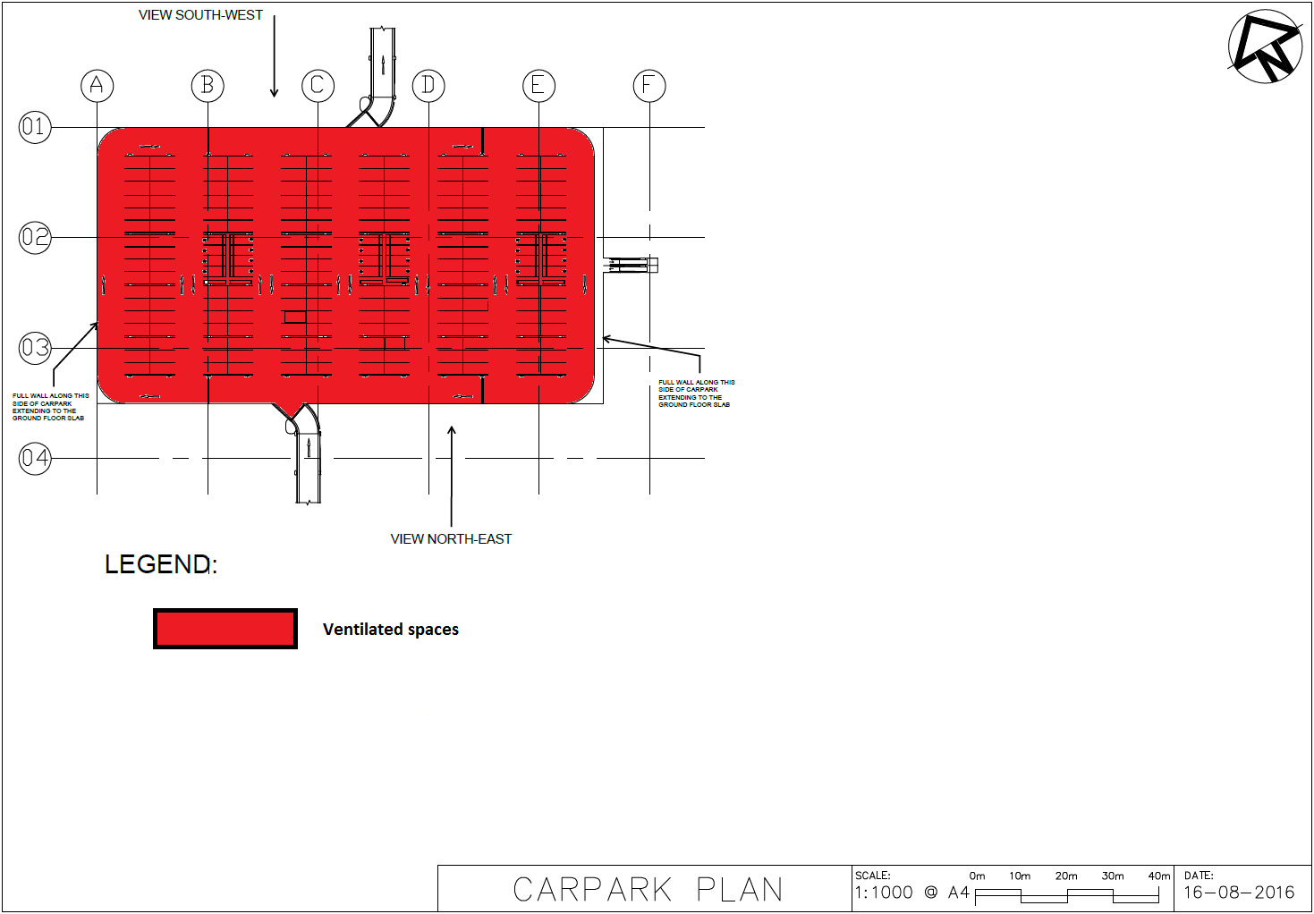

**Figure 3 Overlay of Carpark Plan**

## 2.3 Thermal Zoning and Its Relevant Information in Heat Load Calculations

Thermal zoning is the partition of spaces sharing similar conditioning demands and the same temperature (heating and cooling) set points so that spaces under similar conditions can be air conditioned in one Air Handling Unit (AHU) system and Fan Coil Unit (FCU) system. It consequently reduces number of components in HVAC system with less costs and complexity. With the help of thermal zoning, air conditions can also be adjusted by a single thermostat. A thermal zone may contain either one space or more spaces and can be regarded as the basic thermal unit.

In heat load calculations, thermal sizing plays a role in sizing the HVAC system. Both estimation of building peak load and respective zones airflow rate are needed. Refrigeration capacity is determined by building peak load and thermal zoning contributes to the estimation of airflow rate.

## 2.4 Floor Plan Overlay of Thermal Zoning

In a given distribution system type (HVAC in this assignment), there should be three main factors affecting thermal zoning: Usage, temperature control and solar gain/perimeter or internal location. Usage factor indicates the function of each room. Spaces of same or similar functions can be sorted into the same zone. Temperature control means rooms in one same thermal zone share same or similar condition timing and temperature set points. Solar gain/perimeter or internal location factor shows how solar energy influences conditions of perimeter spaces. Rooms exposed to sun radiation receive higher solar heat resulting in a different air condition requirement from internal rooms’.

There are also two principles need to be considered in thermal zoning – reduce number of thermal zones and diminish complexity of ducts. For the first principle, it mainly deals with cost issues. More thermal zones lead to more AHUs and FCUs, which increases costs. For the second principle, limited to spaces for ducts layout between ceiling and roof, rooms in same thermal zoning cannot be divided very far away. Otherwise, costs increase and there will be not sufficient spaces for ducts layout.

Thermal zoning overlay of ground floor is shown in figure 4 below. M02 is supermarket and orientated towards South [1]. As the only south-orientated supermarket, M02 can be exclusively sorted into Thermal Zone 1. Rooms from 106 to 110 are specialities orientated towards southwest [2]. So these five rooms can be sorted into Thermal Zone 2. Rooms from 101 to 104 are specialities orientated towards northeast [2]. As a result they can be sorted into Thermal Zone 3. Specifications of mall corridor, speciality shops and food courts (outlets) are listed in table 1 below [1]. We can find that summer and winter set points and sensible/latent load per person of these three spaces are the same. Although room 114 has is under the influence of solar conduction, this effect can be neglected because the external wall of room 114 is small. So room 114 can be treated as internal room. Under such circumstance, these three spaces can be picked up to form Thermal Zone 4 together. As the only restaurant on ground floor, MM14 can be individually regarded as Thermal Zone 5 [2]. Considering the fact that MM11, MM12, MM13 and MM15 are four mini majors but are facing towards three completely different directions (east, west and northeast), MM12 and MM13 can be categorized into Thermal Zone 6 and MM15 belongs to Thermal Zone 10, while MM11 is divided into Thermal Zone 7 [2]. Thermal Zone 8 can only cover M01 due to that MM01 is the only major exposed to three directions (northeast, northwest and southeast) [2]. As for food court (seating spaces), this space is exposed to high solar radiation due to large area of glazing. Therefore, we divide this space into two different thermal zones 5 and 11. Thermal Zone 11 is responsible for the perimeter in food court whereas Thermal Zone 5 is mainly for spaces not close to glazing for the sake of a better air conditioning effect. When it comes to the thermal zoning of rooms 115-118 (outlets), sensible and latent load per person of food court (seating) is 80W/80W, which is different from outlets’ sensible and latent load requirement shown in table 1below [2]. However, based on assumption (1) and principle, food court outlets are open spaces, therefore, we combine food court (seating) with rooms 115-118 to form Thermal Zone 9 without single consideration on these four outlets.

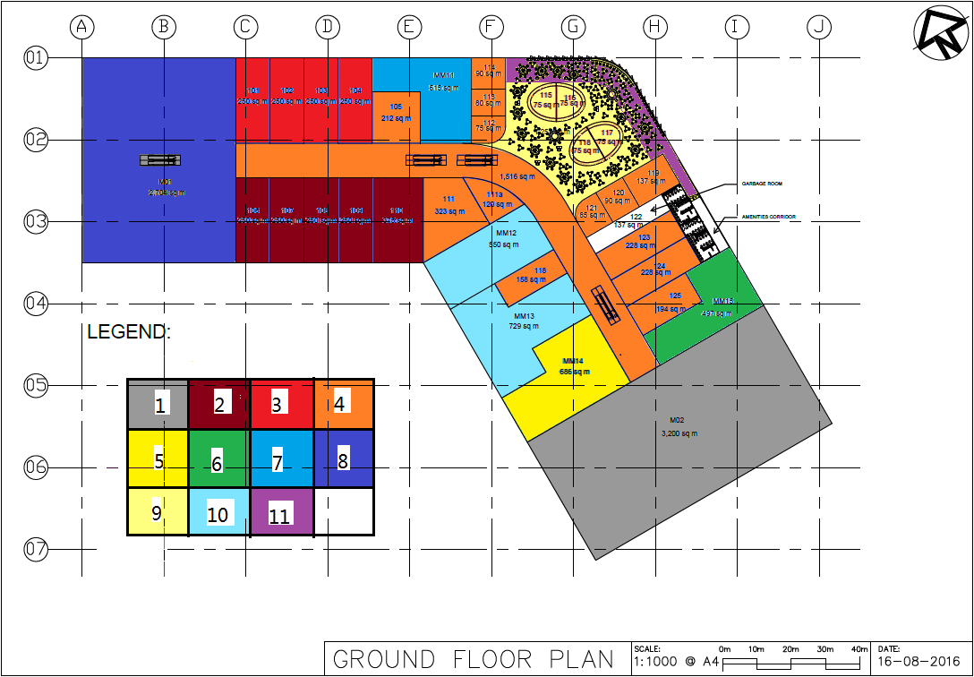

**Figure 4 Thermal Zoning Overlay of Ground Floor**

|  |  |  |  |
| --- | --- | --- | --- |
| **Spaces** | Speciality Shops | Food Court (Outlets) | Mall Including Kiosks |
| **Summer Set Points** | 24oC DB/55% RH | | |
| **Winter Set Points** | 21oC DB/80%RH | | |
| **Sensible/Latent Load Per Person** | 70W/60W | | |

**Table 1 Specifications of mall, speciality shops and food court**

Thermal zoning overlay of first floor is shown in figure 5 below. M01, as the only major on first floor is divided into Thermal Zone 1 [2]. Rooms 201-204 are speciality shops orientated towards northeast, therefore, belong to Thermal Zone 2 [2]. Mall corridor and room 209 can be sorted into Thermal Zone 3 because both of them are inner spaces [2]. Thermal Zone 4 covers rooms 205-208 in that these four rooms are speciality shops orientated southwest [2]. MM22 and MM23 are mini majors with similar orientations (east and southeast) and can be sorted into the same Thermal Zone 5 based on our assumption (2) [2]. MM21 and MM24 are two mini majors with northeastern and eastern orientations [2]. Given that these two rooms share the same air condition requirements and are not far away from each other, we categorize these two rooms into Thermal Zone 6 [2]. Thermal Zone 7 and 9 are the same with Thermal Zone 9 and 11 on ground floor plan. Room 215 is the only restaurant on first floor with two external walls exposed to solar radiation, so it makes up Thermal Zone 8 [2]. Rooms 210 and 212 are cafes but with opposite orientations (east and west) [2]. Therefore, these two cafes belong to Thermal Zone 11 and 10 respectively. Room 212 is speciality shop orientated east, different from all the other speciality shops [2]. As a consequence, it is solely divided into Thermal Zone 12. Rooms 213 and 214 are cafes next to each other. However, exterior wall of 214 is towards south while exterior walls of 213 are towards to south and east [2]. So they receive significantly different solar gain. These two rooms are consequently sorted into Thermal Zone 13 and 14 respectively.

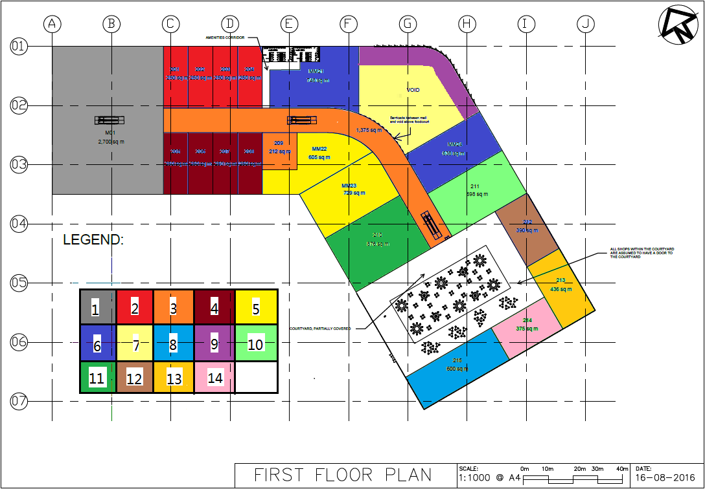

**Figure 5 Thermal Zoning Overlay of First Floor**

Thermal zoning plan of carpark is displayed below in figure 6. The whole carpark belongs to one thermal zone.

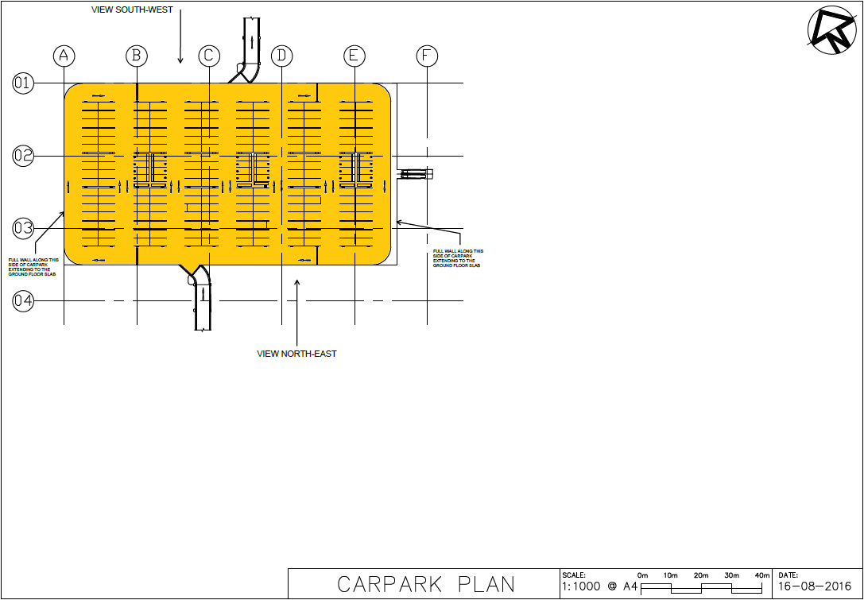

**Figure 6 Thermal Zoning Overlay of Carpark**

# 3. Ventilated Space Calculations

## 3.1 Ventilation Type of Carpark

There are two types of ventilation: natural ventilation and mechanical ventilation. The main difference of these types is if there is mechanical ventilating device for assistance. And criteria focus, as shown below in figure 7 extracted from Figure 4.2 (part) Natural Ventilation of Car, type © [3], on the dimension of internal obstructions and minimum of permanent wall openings.

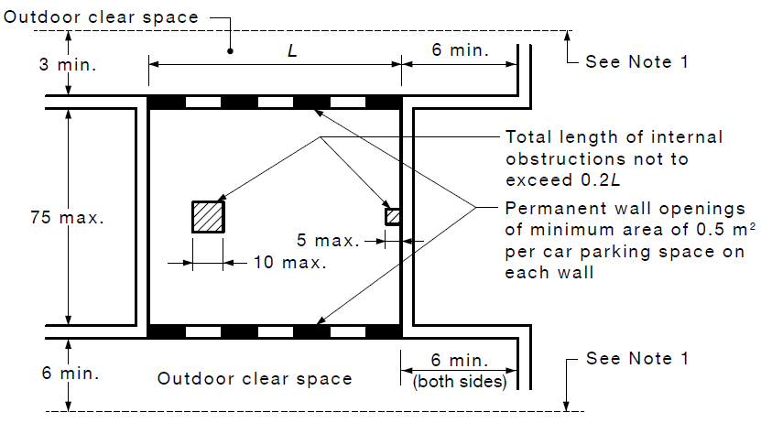

**Figure 7 Criteria of Natural Ventilation of Type © Carpark**

As displayed in figure 8 below, total length of internal obstructions in carpark is 19m [2]. And length of carpark is 110. The ratio of total internal obsturctions to length of carpark is 19/110=0.172<0.2, which satisfies the length requirement of 0.2. Area of permanent wall openings, as shown in figure 8, is (18 in total with height 4.5m, width 5.5m each). The number of car parking spaces is 192 as demonstrated in figure 9 [2]. Therefore, there should be at least permanent wall openings, which is lower than actural openings area. Current carpark conditions, therefore, can meet both two criteria of natural ventilation.

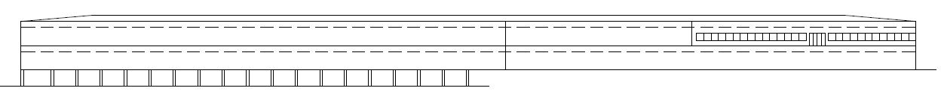**Figure 8 Elevational Views of Building**

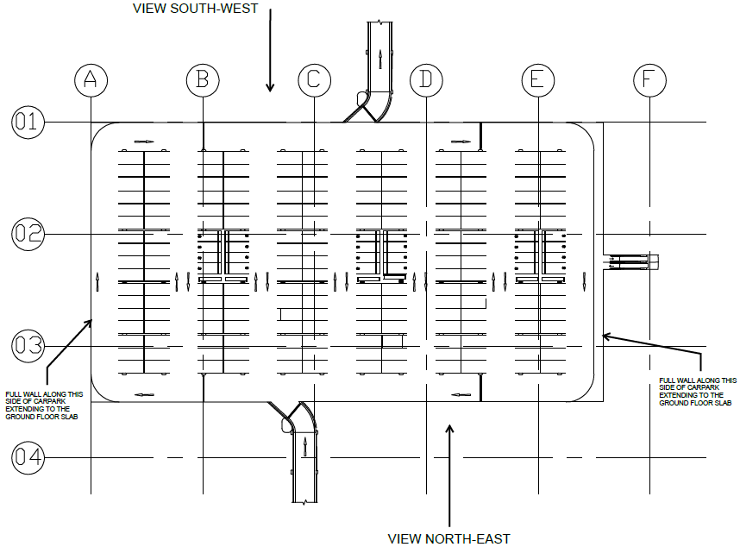

**Figure 9 Carpark Plan**

## 3.2 Smallest Number of Exhaust Systems

Ventilated spaces needed to install exhaust systems include amenities and their corridor on both ground and first floors as well as garbage room on first floor. According to Table 2 demonstrated below extracted from Table 3.2 of Australian Standards, amenities (bathroom) belong to group 1 [2]. As for corridors adjacent to amenities, for the sake of ventilation simplification and cost cut-down, corridors can be sorted to the same group with amenities (3). Garbage room is required to be classified into group 6 in figure 10. Under such circumstance, minimum of exhaust systems is 3 for amenities and corridor on first floor, garbage on first floor and amenities and corridor on ground floor.

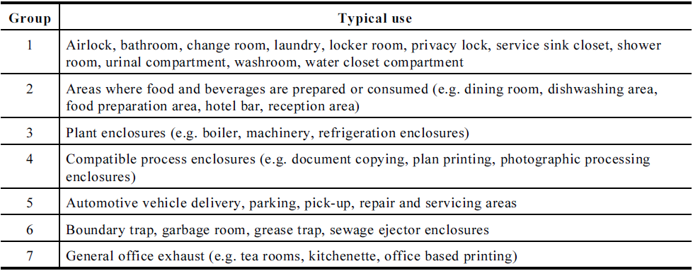

**Table 2 Enclosures That May Be Served by a Common Exhaust System**

## 3.3 Exhaust Rate for Each Ventilated Space

Ventilated spaces with exhaust system include amenities corridor and garbage room on ground floor and amenities corridor on first floor. As stated above in 3.2 smallest number of exhaust systems, each of these three spaces needs their own ventilation system. According to Table B1 from 1668.2 -2012, sanitary compartment requires and garbage room requires [4]. According to measurement, amenities and corridor on ground floor have an area of and amenities and corridor on first floor have an area of [2]. Area of garbage room as listed on Assignment Review is . Exhaust rate of amenities and corridor on ground floor is . Exhaust rate of amenities and corridor on first floor is . And exhaust rate of garbage room on first floor is

# 4. CAMEL Heat Load Simulation

## 4.1 Critical Conditions

Critical conditions are the scenarios that actual instantaneous load comes to its peak. This is measured by the sum of instantaneous external loads and internal loads. External loads include infiltration and heat transfer between walls and solar transmission. Internal loads include heat caused by people, equipment and lights. Critical conditions are used in s

## 4.2 Building Features

### 4.2.1 Partitions

Partition is defined as common walls between rooms. Partitions with heat load added are walls with temperature difference between two sides. According to second law of thermodynamics, it is impossible for heat transfers to happen from low temperature body to high temperature body without external force. Therefore, there must be temperature difference between partition walls for heat transfer with the absence of external force.

### 4.2.2 Roof Loads

Roof loads exist at places connected to roof. In this case, all the rooms on first floor are under influence of roof loads. Besides rooms on first floor, food court and its outlets on ground floor also receive roof loads because it is void right over food court which makes roof loads available for food court and its outlets without conduction obstruction.

### 4.2.3 Skylights

Based on roof plan [1], there are three skylights in total. One interacts with courtyard on first floor. The second interacts with mall. The last one is right over food court (with outlets 115-118) on ground floor as well as void spaces on first floor. As there is no separation between these two spaces, so the third skylight interacts with food court (with outlets 115-118) and void room on first floor.

## 4.3 Simulation and Report of Heating and Cooling Loads

General information is set below in figure 10. Note that building is rotated 30 degrees anticlockwise.

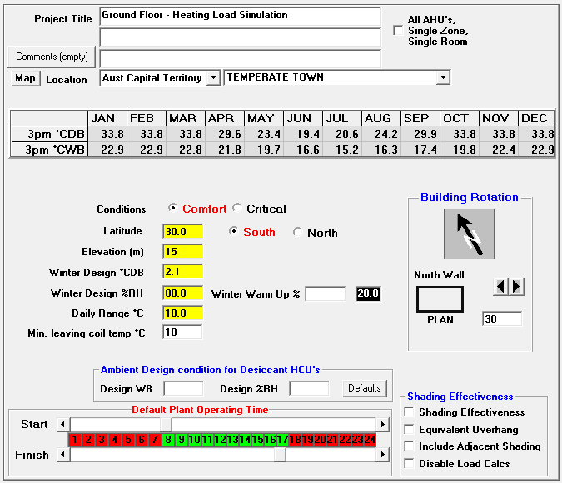

**Figure 10** **Geometry Settings**

### 4.3.1 AHU settings

Based on calculation in manual calculation, reheat system is being used. So VAV with reheat is being used to system type. According to Project Specifications, summer and winter set points for each space are input as the following figure 11 shows. As for operation time, an assumption has been made in Part A that it is between 9am and 9pm the same as Westfield in Sydney (3)[1].

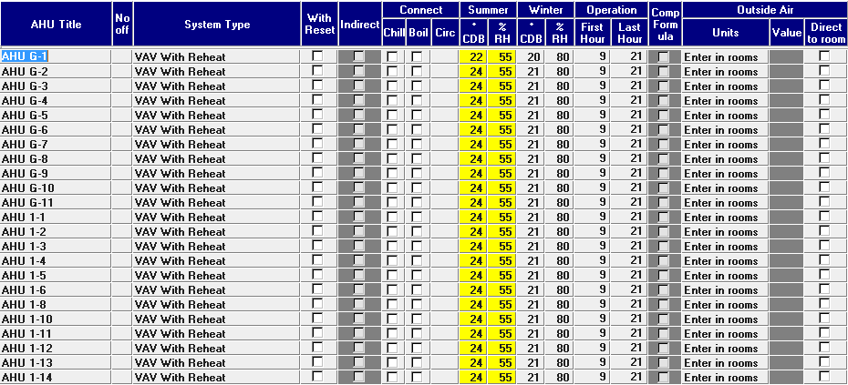

**Figure 11 AHU Settings**

### 4.3.2 AHU Coil Settings

As listed in Project Specifications, we choose Fixed Lvg as psychrometrics type with dry bulb temperature as figure 12 shows [1].

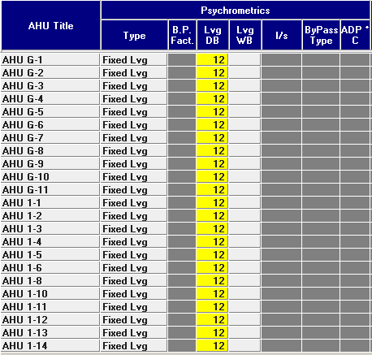

**Figure 12 AHU Coil Settings**

### 4.3.3 Zone and Rooms Descriptions

All rooms and spaces are sorted into their corresponding thermal zones. There is one thing to mention that food court area on first floor is void, which can be regarded as a whole with food court on ground floor and divided into Thermal Zone G9 & G11 as figure 13 displays. Floor areas can be found in floor plans shown in Assignment 1 (2016) – Part A and Part B Overview [2].

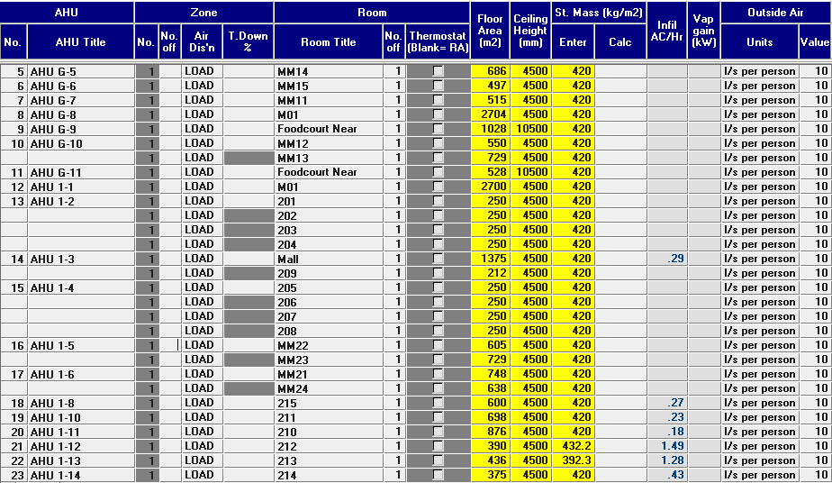

**Figure 13 Zone and Room Descriptions**

Due to the fact food court has a large area of glazing façade and heat load gained from solar is comparably higher in places near the surface than places inside, food court is divided into two thermal zones G9 & G11 and the division line is tangent to rooms 115 and 116. In area calculation, we segment food court into four trapezoids and one rectangle as demonstrated in figure 14 below. Area of thermal zone 9 is, therefore, . Area of thermal zone 11 is . Based on assumption (4), areas of void food court on first floor are the same as areas of their corresponding areas on ground floor. Ceiling of food court is 4500 + 6000 = 10500mm.

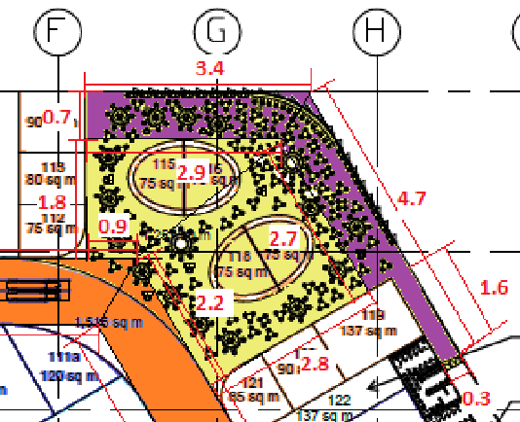

**Figure 14 Segmentation of Food Court**

Storage mass of rooms an be found in Project Specifications except rooms 212 and 213 [1]. Storage mass of rooms 212 and 213 are 432.2 and 392.3 respectively based on manual calculation in Part A.

As for infiltration, Ch/hr depends on exposure, construction, location of windows, type of window, degree of fenestration and Partitioning. Ch/h of each item is shown below in Table 3. According to assignment requirement listed on Amendment – Rev 3, infiltration through windows and doors are only needed to be applied for 212 and 213 and door infiltration is applied for rooms with external walls containing doors [5]. In this way, infiltration happens in rooms 210, 211, 212, 213, 214, 215 and malls on both ground floor and first floor.

 **Table 3 Windows Infiltration Due to Wind Forces**

Room 212 has south wall containing windows without shades. Ch1 = 0 and Ch3=0. Construction factor Ch2 is 0.5 (dry) in summer and (wet) in winter. Based on assumption (5), type of windows all rooms are gasketed. Ch4=0. Degree of fenestration is , (interpolated). Partitioning is nil based on assumption Ch6=0 (6). So AC/hr-windows = Ch1+Ch2+Ch3+Ch4+Ch5+Ch6 = 0.58 in summer and 0.08 in winter.

Room 213 has south wall and east wall containing windows even though south wall is shaded. Under such circumstance, (weighted average). Construction factor Ch2 = 0.5 (dry) in summer and 0 (wet) in winter. These two walls are adjacent, Ch3 = 0. Windows type is gasketed, Ch4 = 0 (5). Degree of fenestration is , (interpolated). There is no partitioning on windows, Ch6 = 0 (5). Therefore, Ch/hr-windows = Ch1+Ch2+Ch3+Ch4+Ch5+Ch6 = 0.91 in summer and 0.41 in winter.

Infiltration through doors can be calculated using , where flow rate is 200L/s (any external entrance to shop) and 500L/s (any external entrance to the mall) obtained from Project Specifications [1]. Volume of 210, 211, 212, 213, 214, 215 and malls on ground and first floor are 3942, 3141, 1755, 1962, 1687.5, 2700, 6822 and 6187.5 respectively with ceiling height 4.5m. So total AC/hr can be obtained in table 4 below.



**Table 4 Total AC/hr in summer and winter**

### 4.3.4 External Walls Settings

External walls settings are shown below in figure 15. This figure includes exposure positions, height and width of each external wall. Shade schematics for façade of food court, mall, 210, 211, 212, 213, 214 and 215 are shown in figure 16. Skylight and windows schematics are demonstrated in figure 17. . Glazing facade outside food court are separated into two parts, one part is on northeast wall of food court and the other part is on the east wall of food court. Structure of these two parts are demonstrated in figure 18.

Wall/roof type includes two parameters, i.e. U-value and surface density. U-value of each wall can be found in Project Specifications, hence, we can choose a material with similar U-value in Camel and use its surface density [1]. W112 is used for all external walls and R46 is selected for all roofs except 212 and 213 (7). Considering the complexity of roof of 212 and 213, no similar wall can be found in Camel wall settings, hence, an assumption is made that its density is (8). As for glazing surface density, 4mm thick pane weighs , therefore, glazing with thickness 6mm should be , which is proportional to its thickness (9). Wall types are demonstrated in figure 19. Another significant assumption made on ceiling and roof is that U-value of ceiling is the same as the U-value of upper floor (for the first floor, U-value of ceiling is the same as U-value of roof) (10). This assumption can be proved valid because the false ceiling space (1.5m air space) is void that it facilitates ducts installation, repairment and even amendment for future use (11).

Another significant assumption is about walls surrounding court yard. Since court yard is neither air conditioned nor ventilated and there is a large skylight on the roof of court yard, all walls with an entrance to court yard can be treated as external walls with shelter on the top (12).

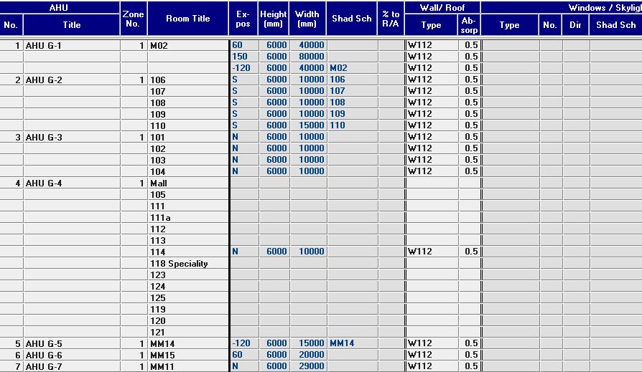

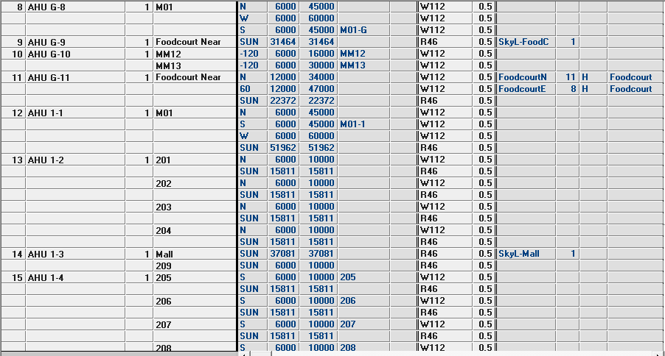

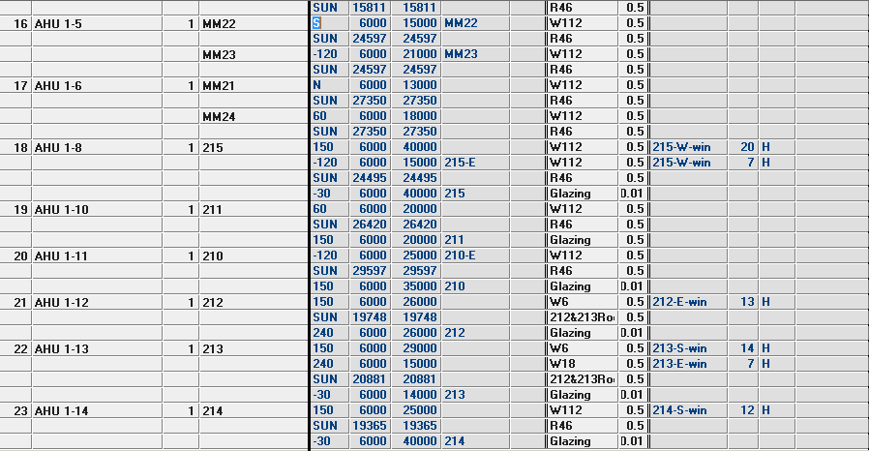

**Figure 15 External Settings**

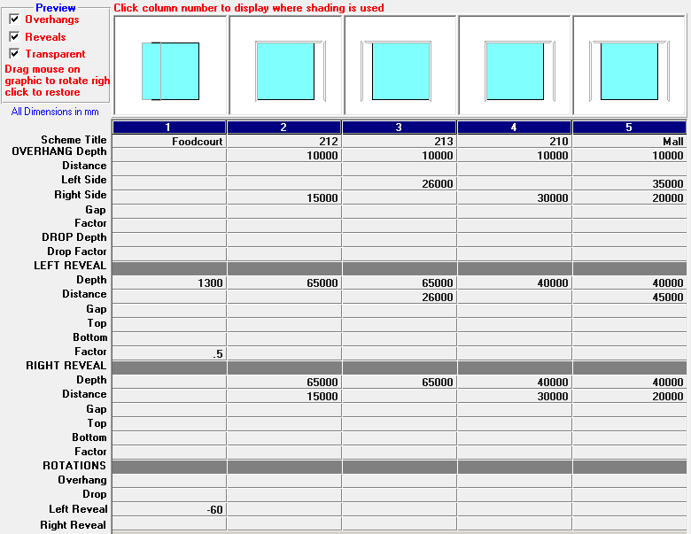

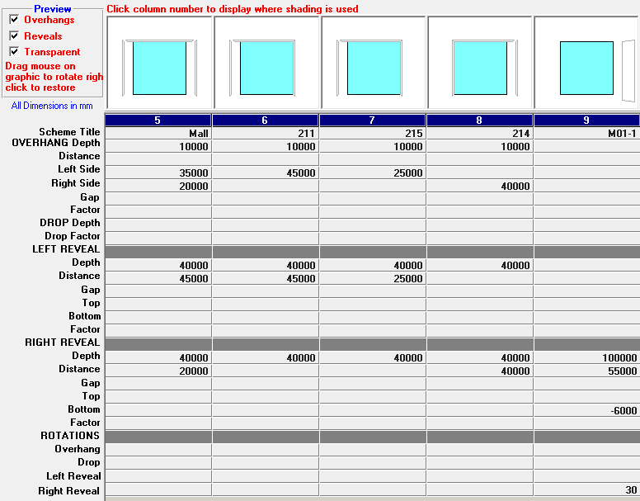

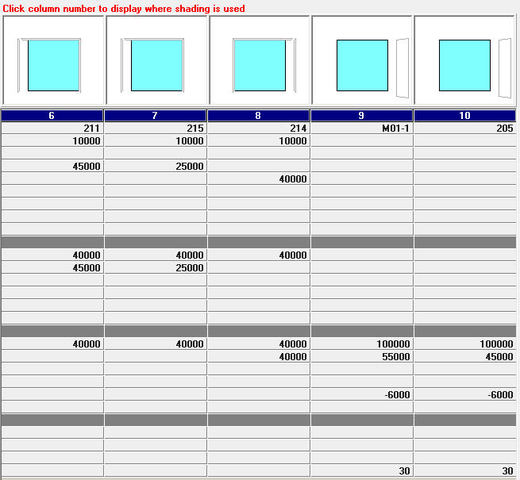 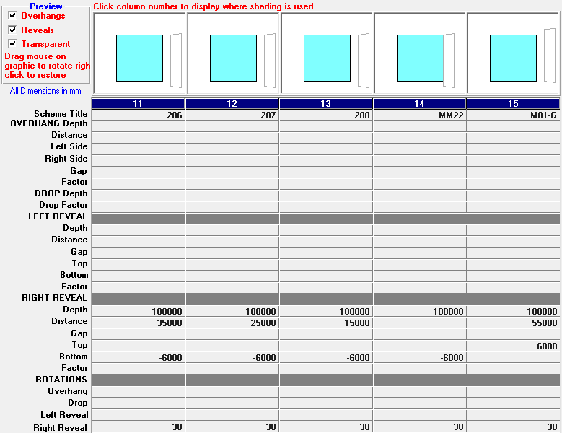

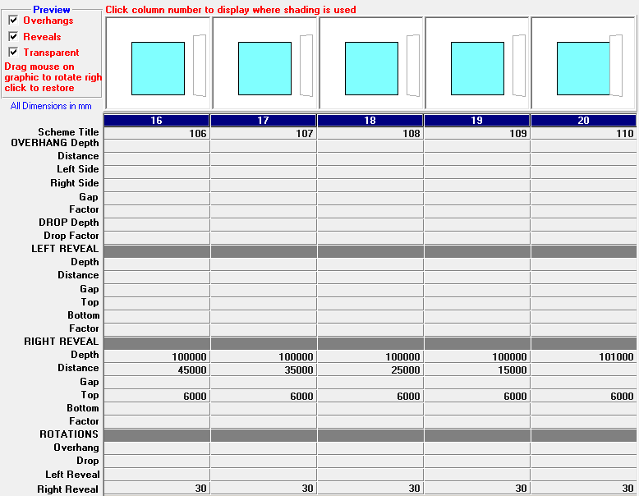

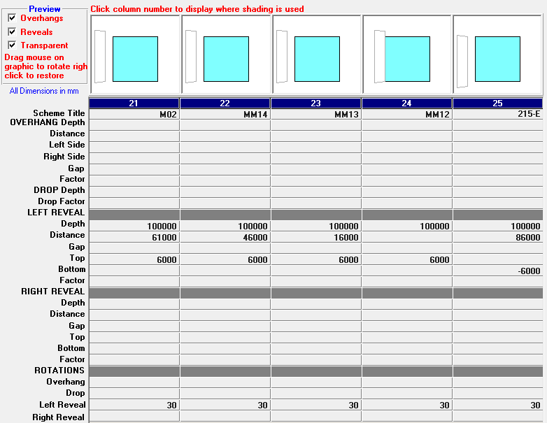

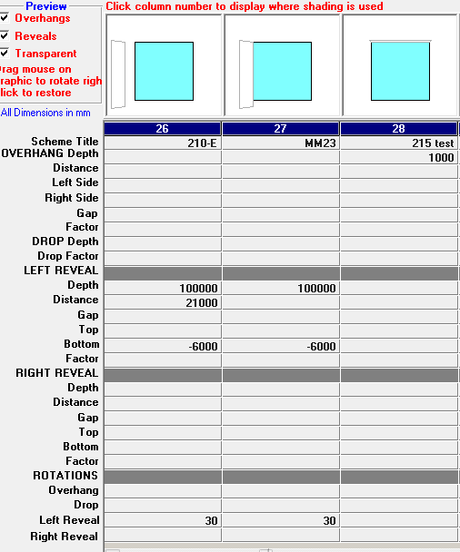

**Figure 16 Shade Schematics**

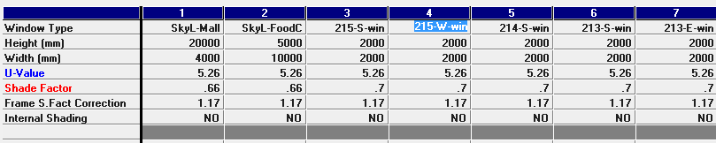

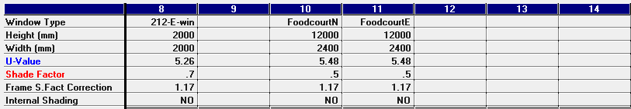

**Figure 17 Skylights and Windows Schematics**

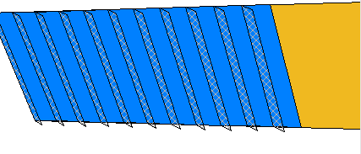

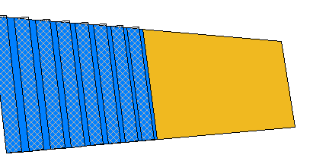

**Figure 18 Structure of Glazing of Food Court**

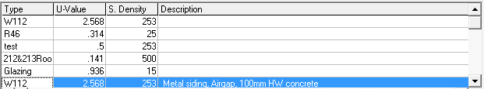



**Figure 19 Wall Types**

### 4.3.5 Partitions Settings

Partitions setting are shown in figure 20 below. Partitioning areas need to be calculated where this is temperature difference between two rooms, i.e., walls between two adjacent air conditioned rooms with different temperatures and walls between air conditioned room and ventilated rooms. Two flags are used for cooling and heating – C (constant temperature of adjacent space) and P (proportion of temperature difference between current space and ambient air). Constant temperature of adjacent space is used in partitioning between two air conditioned rooms whose temperature can be maintained stable. And proportion of temperature difference between current space and ambient air is used in situation where partition wall is between air conditioned room and ventilated room.

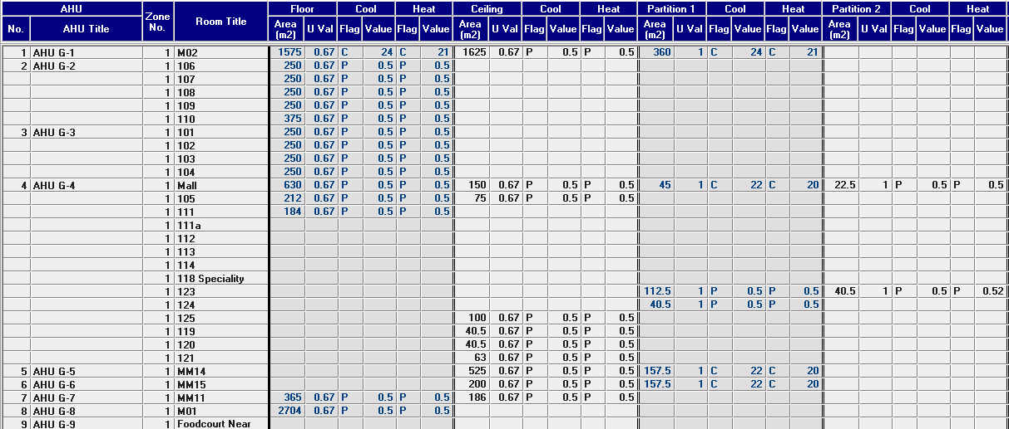

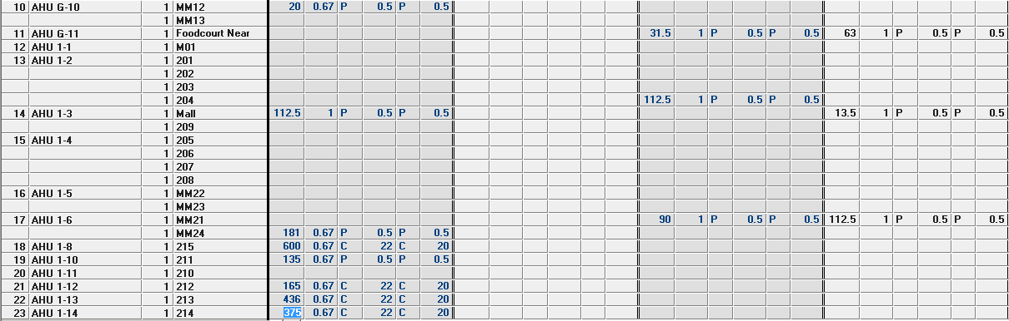 **Figure 20 Partitions Settings**

First floor partitions between ground floor and first floor is shown in figure 21. MM24 in thermal zone 6 and 211 in thermal zone are over garbage and amenities belonging to ventilated spaces, therefore, corresponding floor partitions are P type. Due to M02 on ground floor is supermarket with different set points from all other air conditioned rooms, so there is constant temperature difference between M02 and any rooms adjacent to M02 on first floor including 212, 213, 214 and 215. As shown in figure 21, all partitions with heat transfer from ground floor are displayed with a less saturated colours than their original colours. Besides these partitions, 204, MM21 and Mall surrounding amenities are P type partitions.

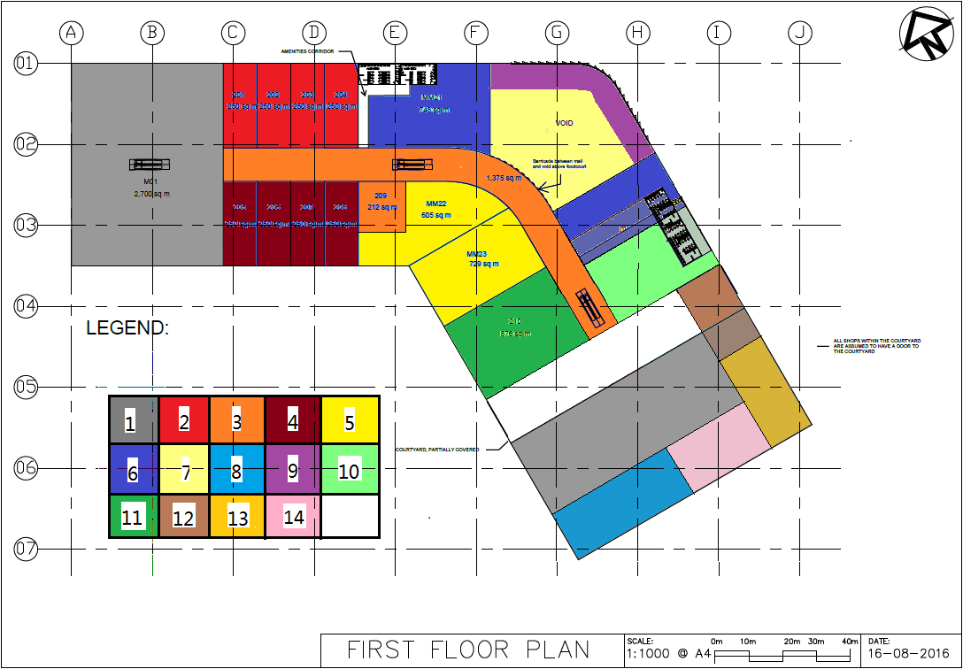

**Figure 21 First Floor Partitions Between First Floor and Ground Floor**

Ground partitions are displayed in figure 22 below. Due to carpark is naturally ventilated, any floor of air conditioned rooms on ground floor right over carpark is P type partition. There partitions are displayed in less saturated colours compared with their original colours. At the same time, amenities are right over 105 and M11, which result in type P ceiling partitions. Ceiling partitions of 105 and MM211 are demonstrated with much less saturated colours. Since M02 has set points different from all other air conditioned rooms, part of ceilings of M02 are C type partitions caused by 212, 213, 214 and 215. Part of ceilings of M02 is P type partitions caused by court yard on first floor. At the same time, ceilings of MM14, Mall, 125 and MM15 are type P partitions. Besides partition walls, any walls adjacent to amenities and garbage are type P partitions including walls of 119, 120, 121, Mall, 123, 124 and MM15. Also, any rooms next to M02, i.e., MM14, MM15 and Mall have type C partitions.

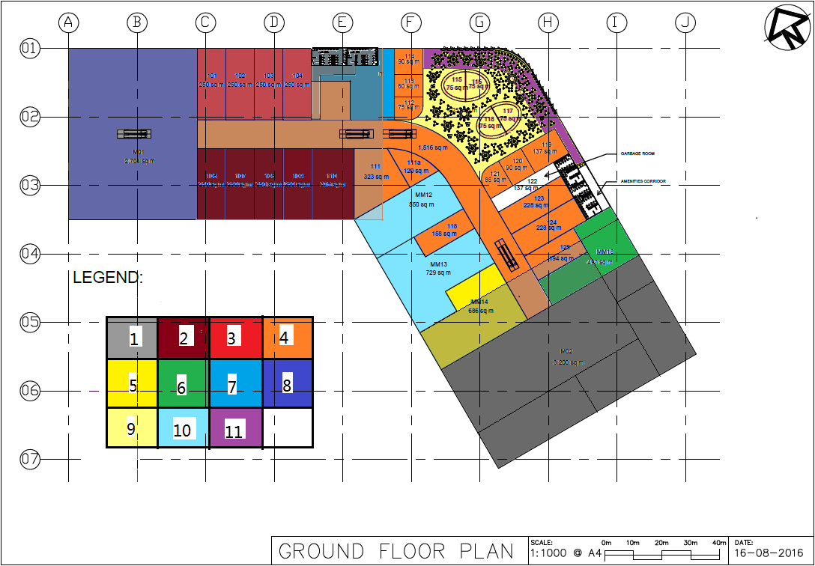

**Figure 22 Ground Floor Partitions between First Floor and Ground Floor and Between Ground Floor and Carpark**

### 4.3.6 Internal Heat Loads Settings

Internal loads parameters are set in figure 23 below. Data can be found in Project Specifications [1]. . Activity level for restaurant is 7 while any shop except restaurant has level activity of 4.

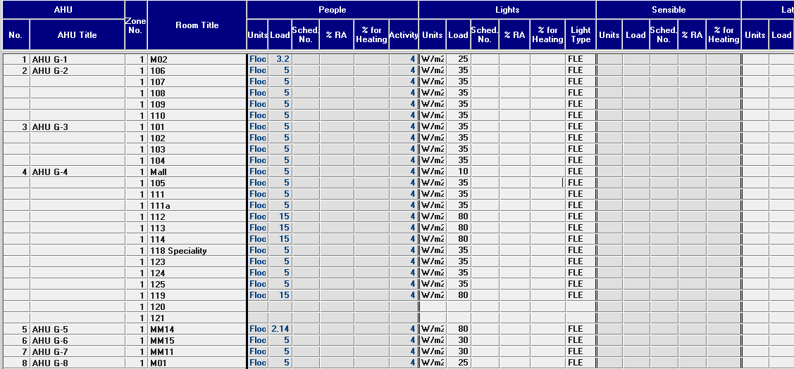

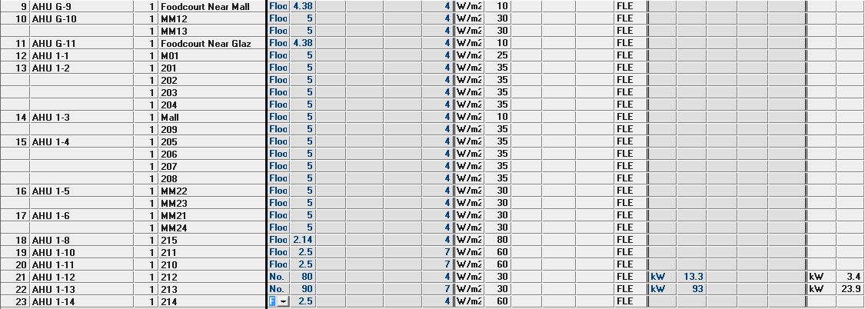

**Figure 23 Internal Loads Settings**

# 5 Validation of Heating and Cooling Load Calculation

## 5.1 Report Part A and Part B Calculations and Provide a measure of Similarity

Similarity can be compared in terms of cooling heat in summer and heating load winter. Heat loads cover both sensible heat and latent heat. Heat loads extracted from Part A is demonstrated in table 5 and table 6 below. Camel simulation outcomes of heating load are attached to Appendix 1. Summary of cooling result is displayed in table 7 below.

|  |  |  |
| --- | --- | --- |
| **Item** | **Sensible heat (W)** | **Latent Heat (W)** |
| Heat Gain Through Exposed Walls | 9010 | 0 |
| Heat Gain Through Partitions | -120.3 | 0 |
| fInternal Loads | 38839.1 | 15351 |
| **Total** | 47728.8 | 15351 |

**Table 5 Cooling Load of 212 in Summer**

|  |  |  |
| --- | --- | --- |
| **Item** | **Sensible heat (W)** | **Latent Heat (W)** |
| Heat Gain Through Exposed Walls | 7568.1 | 0 |
| Heat Gain Through Partitions | -317.8 | 0 |
| Internal Loads | 120526.1 | 37943 |
| **Total** | 127776.4 | 37943 |

**Table 6 Cooling Load of 213 in Summer**

|  |  |  |
| --- | --- | --- |
| **Rooms** | **Sensible Heat (W)** | **Latent Heat (W)** |
| **212** | 45611 | 14264 |
| **213** | 134687 | 38173 |

**Table 7 212 and 213 Cooling Result of Camel Simulation**

## 5.2 Comparison Between Camel Simulation and Hand calculation for Rooms 212 and 213

Difference between Camel simulation and hand calculation in sensible heat of room 212 is . Difference between Camel simulation and hand calculation in latent heat of room 212 is . Difference between Camel simulation and hand calculation in sensible heat of room 213 is . Difference between Camel simulation and hand calculation in latent heat of room 213 is . And the average of these four percentages is . It can be concluded from these data that all the differences between hand calculation and Camel simulation are less than 8%. And the average difference is lower than 5%.

Three important reasons for these differences is that we suppose

1. Camel running is based on hourly data, it cannot run simulation on a specific time.
2. Assumptions made in Part A are different from Camel default settings.
3. Ideal situations are utilised to simplify calculation, which results in variation in realistic situations.

## 5.3 Safety Factors and Diversity Factors

Safety factor is a factor added to the sub-total of room sensible heat in order to account for any unsureness. The total value of sensible heat is the sub-total plus percentage additions for the following four items: (1) supply duct heat gain, (2) supply duct leakage losses, (3) fan power and (4) safety factor. Safety factor is usually chosen from 0% to 5%. The percentage additions to latent heat for items (2) and (4) are the same with room sensible heat.

Diversity factor is ratio of total output capacity of HVAC system to the total capacity of all TAUs (Terminal Air Units) connected to this HVAC system. It usually varies within range of 70% - 80%.

# 6 Air Schematics

## 6.1 Purpose of Air Schematics and Information Provided

Air schematics are utilised to extract main features from layout of an air conditioned building. It demonstrates major parameters such as supply air rate, outside air rate and exhaust air rate in a simplified way for facilitation in duct layout following and checking.

Air schematics in HVAC can provide information about project type, thermal zones, relevant air rates of each room, location and number of fans and AHUs and riser capacity requirement. Air schematics also demonstrate a preliminary duct layout with air flow division and combination points. Therefore, air quantity and duct dimension can be determined based on air schematics.

## 6.2 Air Schematics Construction

Seven Air schematics are displayed in figure 34-30 below.

# 7 Duct Design

## 7.1 Difference in Maximum Airspeeds of Main and Branch Ducts

When main ducts branch out into branch ducts, there must be a fitting. When air flows through fitting, a pressure loss happens. Consequently, air speed decreases in such situation.

## 7.2 Pros/Cons of Reducing Duct Size

Reducing duct size can directly bring the cost down. But for the same flow rate, air velocity increases, which leads to more vibration and noise. Moreover, air pressure increases which can result in more infiltration through ducts connections.

## 7.3 Riser and Its Purpose

Riser is a hollow duct that rises vertically through a construction. The purpose of riser is to provide vertical channel to allow duct or cable to pass through different floors.

## 7.4 Riser Location and Size

Riser location should be located at the corner or at least next to the wall for aesthetic requirement and less compromise on rooms function. It is better to locate in the thermal zones it serves or at least near the thermal zones. Being far away from its thermal zones means longer ducts which may result in higher cost, higher pressure loss and more complex layout.

Size of riser doesn’t directly rely on total air flow running through riser. In fact, its size should be the sum of ducts it contains. One thing to mention is that ducts in riser cannot be completely tightly arranged without gaps.

## 7.5 Duct Overlay

In order to plot duct overlay, flow rates of supply air, outside air, return air and exhaust air need to be calculated first. Supply air and outside air flow rates of each of room and thermal zone can be found from Camel simulation outcome. Then, return air flow rate can be obtained by using formula . Exhaust air flow rate equals to flow rate of outside air. Flow rates of these four types air are displayed in table 8 below.

After air flows are obtained, duct branch and number of grilles, then, can be figured out. Each grille for supply air is able to spread 300L air per second and grille for room air can spread 1000L air per second [1]. Therefore, number of supply air grilles and number of return air can be calculated by using  and . Each point on branch duct can connect four grilles with flexible ducts. Then, number of ducts is available . Note that all numbers no matter about grilles or branch duct need to be rounded up to the next higher integer. Grilles number and branch number are demonstrated in **table** as well.

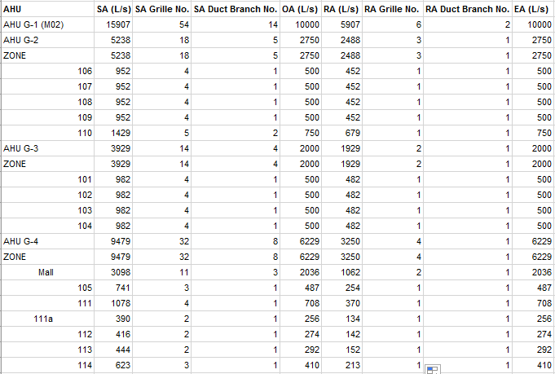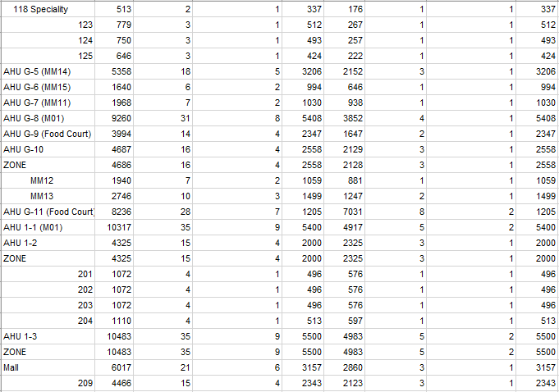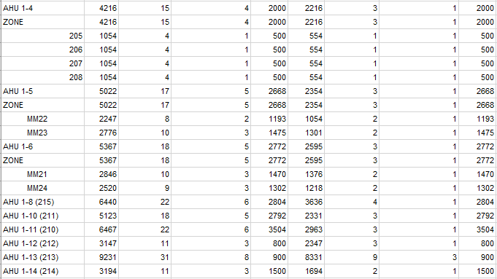

**Table 8 Parameters of Supply Air, Outside Air, Return Air and Exhaust Air**

Histograms of SA flow rate and RA flow are shown in figure 31and figure 32 respectively. The ranges of SA flow rate and RA flow rate are [416,15907] and [274,10000] respectively. It is easy to find that maximum of both SA flow rate and RA flow rate is 15907 L/s and minimum is 274 L/s.

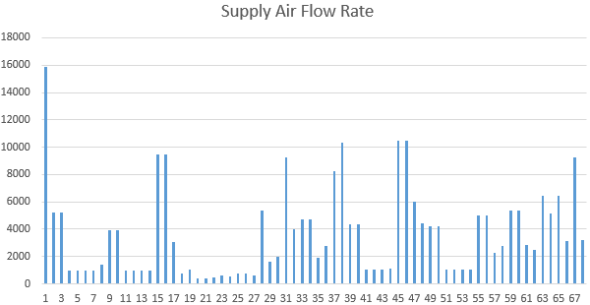

**Figure 31 Supply Air Flow Rate Histogram**

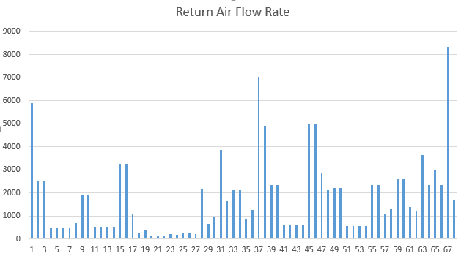

**Figure 32 Return Air Flow Rate Histogram**

Given that each point of branch duct can be connected with four grilles, therefore, 1200 L/s (4x300L/s=1200L/s) is selected as a step length to divide interval into 14 sub-intervals: [0, 1200), [1200, 2400), [2400, 3600), [3600, 4800), [4800, 6000), [6000, 7200), [7200, 8400), [8400, 9600), [9600, 10800), [10800, 12000), [12000, 13200), [13200, 14400), [14400, 15600) and [15600, 16800). But the length of interval [15600, 16800) is small, hence, it can be integrated into [14400, 15600) and then we get interval [14400, 16000). Also, there is no flow rate of 10800, 13200 and 14400, therefore 11000,13500 and14500 are used to replace former ones in that the latter three flow rates are bigger and will lead to a larger duct. All duct types are shown in table 9below.



**Table 9 Duct Type and Max Flow Rate**

Once max flow rate of each duct type is determined, duct sizes can be chosen by Ductulator. Ductulator is a software/APP that is designed to calculate circular duct diameter and its equivalent rectangular duct dimensions with inputs of flow rate and velocity or friction loss (pressure drop). According to Project Specification, friction loss is 1Pa/m and velocity is 7.5m/s, which are displayed in figure 31 below [1]. The intersection of these two limitations is 1700L/s. Therefore, flow rate smaller than 1700L/s should just reach the friction loss limitation and flow rate bigger than 1700L.s should exactly reach to the velocity limitation.

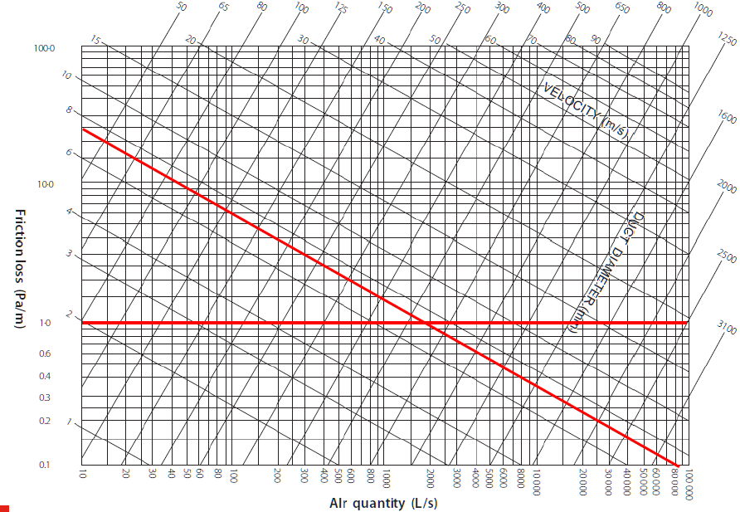

**Figure 31 Friction Loss and Velocity Limitations**

Duct is designed as circular one with diameter parameter in calculation process, and then converted to its equivalent rectangle sizes with height and width parameters as shown in figure 32 below. One thing to note that rectangular duct is sized in increments 50mm or 100mm especially for large size ducts (more than 350x500mm). Hence, all height and width of rectangular duct need to be rounded up to 50 or 100mm. In Ductulator settings, 7.4m/s velocity is used because there is no 7.5m/s input parameter. Under such circumstance, sizes calculated by 7.4m/s can satisfy the situation in 7.5m/s. The same method is used dealing with air flow rate of 10800, 13200 and 14400. These three parameters are enlarged to 11000, 13500 and 14500 respectively so that the rectangular sizes are safely higher than the result of original parameters. All screen shots of the Ductulator result are demonstrated in appendix 2.



**Table 32 Duct Types and Rectangle Sizes**

Ground floor duct layout and first floor duct layout are displayed in the following figure 34 and figure 35. Note that branch duct type of supply air is DT1 because DT1 can completely satisfy the maximum supply air flow rate of four grilles, i.e., 1200L/s. Detailed segments of ground floor and first floor duct layouts can be found in Appendix 3.

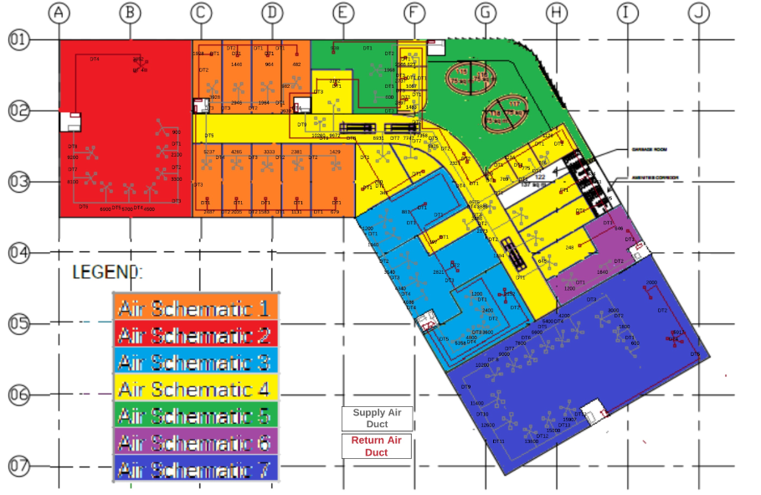

**Figure 34 Ground Floor Duct Design**

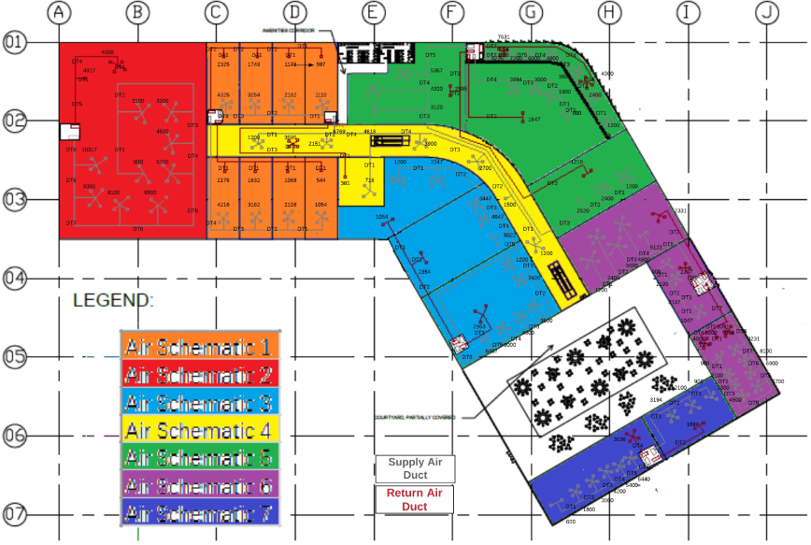

**Figure 35 First Floor Duct Design**

# 8 Pressure Loss Calculation and Fan Selection

## 8.1 Index Run

Duct pressure loss is the pressure that needs to be overcome by the fan to push a required air amount to outlet. Duct running is the path of air flowing. And index run is duct running with the highest pressure drop. Note that index run is not always the longest duct running.

## 8.2 Index Run on All Supply and Exhaust Systems

Supply air duct layout of garbage and amenities on ground floor is shown in the following figure 35. Supply air duct layout of amenities on first floor is displayed in figure36 below. When tube 2-3 and tube 1-3 intersect at point 3 and then a duct is placed vertically to send exhaust air to roof. Note that there is supply air system used in ventilation system. Air is supplied through infiltration through doors and windows. As stated in section 2, exhaust air flow rates of garbage and amenities on ground floor are 610L/s and 1660L/s respectively. And exhaust air flow rate of amenities on first floor is 2220L/s. Flow rate and its change is labeled on the layout as well.

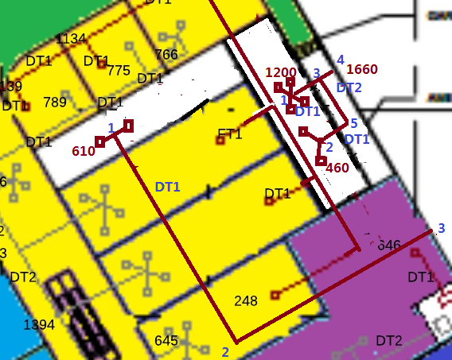

**Figure 35 Exhaust Air Duct Layout of Garbage and Amenities on Ground Floor**

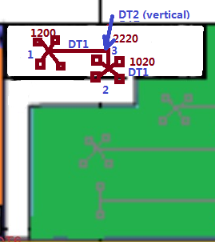

**Figure 36 Exhaust Air Duct Layout of Amenities on First Floor**

Ducts in ventilation are DT1 and DT2, we choose No.021. Relevant parameters are displayed in figure 37 below. Aspect ratio of DT1 is , therefore nearest is 1.07. Aspect ratio of DT2 is , therefore the nearest is 1.27.

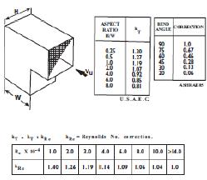

Figure 37 No.021 Parameters

1. For garbage on ground floor, straight duct pressure loss between 1 and 2:

, where L can be measured

Straight duct pressure loss between 2 and 3:

, where L can be measured

Fitting loss at point 2:

Therefore, pressure loss of duct run 1-2-3: , where pressure losses associated with intakes, grilles and flexible connections is 100Pa according to Project Specification [1].  
Hence, index run of garbage is 1-2-3 with 131.7 Pa pressure loss.

1. For amenities on ground floor, straight duct pressure loss between 2 and 5:

, where L can be measured

Straight duct pressure loss between 5 and 3:

, where L can be measured

Straight duct pressure loss between 1 and 3:

, where L can be measured

Straight duct pressure loss between 3 and 4:

, where L can be measured

Fitting pressure loss at point 5:

Fitting pressure loss at point 3:

Junction 601 is chosen, relative parameters are shown in figure 38 below:

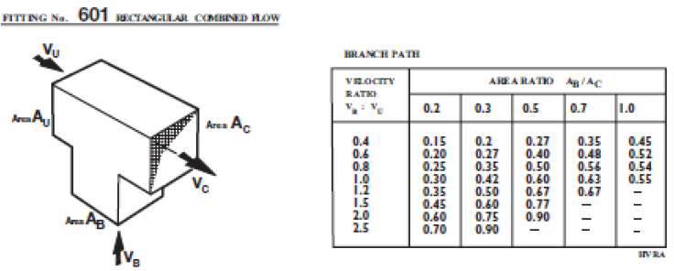

**Figure 38 No.601 parameters**

Velocity ratio is , the nearest value is 0.4. Area ratio is . Thus, is 0.31 (interpolated).

Therefore, pressure loss of duct run 2-5-3-4:

Pressure loss of duct run 1-3-4:

Then, the index run of exhaust air is 2-5-3-4 with pressure loss 112Pa.

1. For amenities on first floor, straight duct pressure loss between 1 and 3:

, where L can be measured

Straight duct pressure loss between 2 and 3:

, where L can be measured

Straight duct pressure loss between 3 and roof:

, where Lis the height of false ceiling.

Fitting pressure loss at point 3:

Junction 601 is chosen at point 3. Velocity ratio is , the nearest value is 1 in **figure** . Area ratio is . Thus, is 0.61 (interpolated).

Hence, pressure loss of duct run 1-3-roof: .

Pressure loss of duct run 2-3-roof: .

The index run, therefore, is 1-3-roof with pressure loss 110Pa.

## 8.3 Formula for Pressure Loss of Straight Duct and Duct Fittings

Pressure loss in straight duct can be calculated by using formula , where is the pressure drop (Pa) in total through straight duct, L is the duct length (SI), is the hydraulic diameter (SI),  is the velocity of circulating air in equivalent circular duct (SI). , is flow rate and A is the duct cross section area.

Pressure loss in duct fittings can be calculated by using , where is the pressure loss, is the loss coefficient for fitting and  is the velocity pressure (Pa). can be obtained by formula and because is nearly 1.2 kg/m3.

## 8.4 Calculation and Report of Pressure Loss along the Index Run

Index run of garbage and amenities on first floor and amenities on ground floor is calculated in 8.2.

## 8.5 Three Factors in Fan Selection

There are three factors when fans are selected: noise, pressure loss and its efficiency. For shopping mall, air flow powered by fan is much than family use fans, therefore, noise is louder than ordinary fans. In this situation, noise produced by fan can not by neglected. The second factor is pressure loss. Pressure loss is overcome by fans, if fans cannot produce sufficient power to provide driving force, HVAC will not work in conditions we design. Efficiency is the last factor we need to consider. As stated before, fans of this shopping mall face a high work load because of high flow rate. Any high efficient fan can save a large amount of energy.

## 8.6 Fans Selection

Based on Fans by Fantech Selection Program, inputs of amenities on ground floor are displayed in figure 39 below. And searching outcome is demonstrated in figure 40 below.

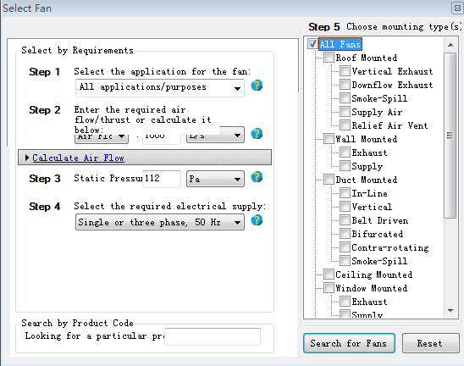

**Figure 39 Inputs of Amenities on Ground Floor**

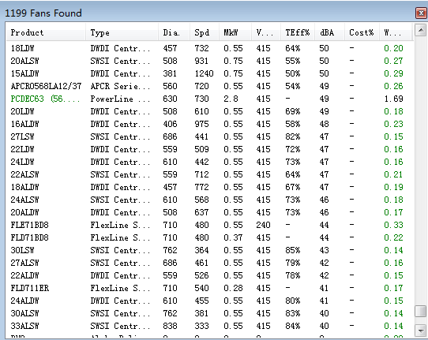

**Figure 40 Searching Result of Amenities on Ground Floor**

There are two fans with quietest sound (40dBA):30ALSW and 33ALSW. But 33ALSW has higher efficiency 84%. Therefore, 33ALSW is chosen for amenities on ground floor.

Inputs of garbage on ground floor are displayed in figure 41 below. And searching outcome is demonstrated in figure 42 below. It is found that 18ALSW has the lowest noise 37dBA. Therefore, 18ALSW is chosen as fan for garbage on ground floor.

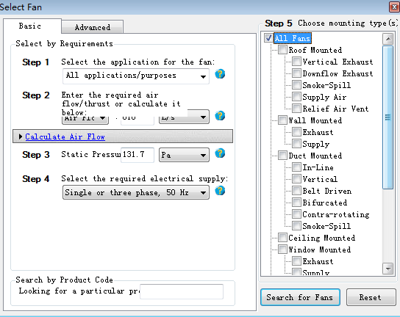

**Figure 41 Inputs of Garbage on Ground Floor**

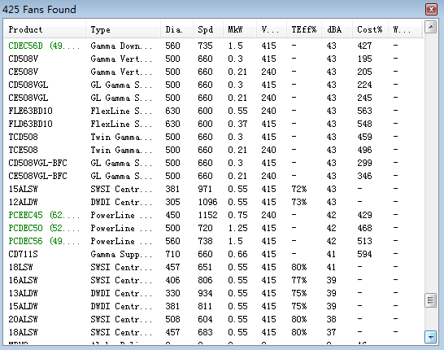

**Figure 42 Searching Result of Garbage on Ground Floor**

Inputs of amenities on first floor are displayed in figure 43 below. And searching outcome is demonstrated in figure 44 below. It is found that 33ALSW, 36ALSW and 40ALW have the lowest noise 37dBA. However, 36ALSW has the highest efficiency of 84% Therefore, 36ALSW is chosen as fan for garbage on ground floor.

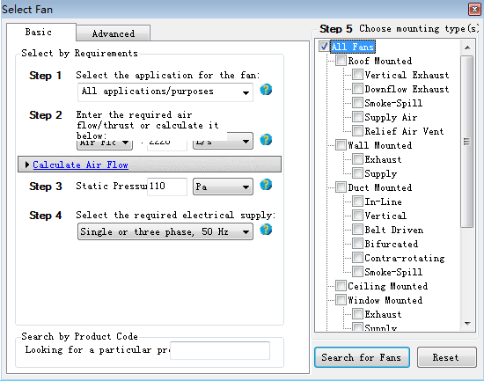

**Figure 43 Inputs of Amenities on First Floor**

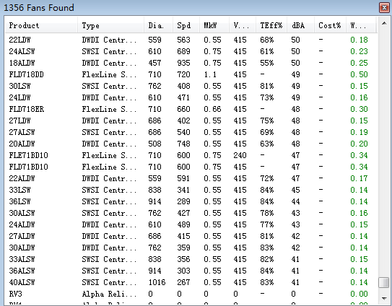

**Figure 44 Searching Result of Amenities on First Floor**

# 9 AHU Selection

According to Camel simulation outcome, sensible heat and air flow rate of each AHU is listed in table 10 below. These two parameters are used as crucial criteria for AHU selection.

|  |  |  |
| --- | --- | --- |
| **AHU** | **ADJ. SENS** | **S/A** |
|  | kW | l/s |
| AHU G-1 | 192 | 15907 |
| AHU G-2 | 75.9 | 5238 |
| AHU G-3 | 56.9 | 3929 |
| AHU G-4 | 149 | 10260 |
| AHU G-5 | 77.7 | 5358 |
| AHU G-6 | 23.8 | 1640 |
| AHU G-7 | 28.5 | 1968 |
| AHU G-8 | 134 | 9260 |
| AHU G-9 | 57.9 | 3994 |
| AHU G-10 | 67.9 | 4687 |
| AHU G-11 | 119 | 8236 |
| AHU 1-1 | 150 | 10317 |
| AHU 1-3 | 98.1 | 6769 |
| AHU 1-4 | 61.1 | 4216 |
| AHU 1-5 | 72.8 | 5022 |
| AHU 1-6 | 77.8 | 5367 |
| AHU 1-8 | 93.3 | 6440 |
| AHU 1-10 | 74.2 | 5123 |
| AHU 1-11 | 93.7 | 6467 |
| AHU 1-12 | 45.6 | 3147 |
| AHU 1-13 | 134 | 9231 |
| AHU 1-14 | 46.3 | 3194 |

**Table 10 AHU Sensible heat and Flow Rate**

EUROKLIMAT is a company providing AHU products. Based on its website, floor standing direct expansion air handling unit with condenser 30000-60000m3/h is an ideal series. Its relative parameters are demonstrated in table 11 below.

|  |  |  |  |  |  |  |
| --- | --- | --- | --- | --- | --- | --- |
| Model | Indoor unit | EKDX300-75A/ EKDX300-75AR | EKDX300-150A/ EKDX300-150AR | EKDX400-200A/ EKDX400-200AR | EKDX500-250A/ EKDX500-250AR | EKDX600-300A/ EKDX600-300AR |
| Outd-oor unit | 2xEKAA150AB/ | 4xEKAA150AB/ | 8xEKAA100AB/ | 8xEKAA125AB/ | 8xEKAA150AB/ |
| 2xEKAA150ARB | 4xEKAA150ARB | 8xEKAA100ARB | 8xEKAA125ARB | 8xEKAA150ARB |
| Nominal cooling capacity (1) | kW | 75 | 150 | 200 | 250 | 300 |
| Nominal heating capacity (1) | kW | 82.5 | 165 | 220 | 275 | 330 |
| Nominal cooling capacity (2) | kW | 65 | 126 | 169 | 208 | 252 |
| Nominal heating capacity (2) | kW | 71.5 | 138 | 186 | 228 | 276 |
| Air flow | m3/h | 30000 | 30000 | 40000 | 50000 | 60000 |
| Air flow | L/s | 8333.333333 | 8333.333 | 11111.11 | 13888.89 | 16666.67 |

**Table 11 Parameters of Floor Standing Direct Expansion Air Handling Unit With Condenser 30000-60000m3h offered by Euroklimat**

Therefore, AHU selection for each thermal zone is listed in table 12 below.

|  |  |  |  |  |
| --- | --- | --- | --- | --- |
| **AHU** | **ADJ. SENS** | **S/A** | Indoor Unit | Outdoor Unit |
|  | kW | l/s |  |  |
| AHU G-1 | 192 | 15907 | EKDX600-300A | 8xEKAA150AB |
| AHU G-2 | 75.9 | 5238 | EKDX300-75A | 4xEKAA150AB |
| AHU G-3 | 56.9 | 3929 | EKDX300-75A | 2xEKAA150AB |
| AHU G-4 | 149 | 10260 | EKDX400-200A | 8xEKAA100AB |
| AHU G-5 | 77.7 | 5358 | EKDX300-75A | 4xEKAA150AB |
| AHU G-6 | 23.8 | 1640 | EKDX300-75A | 2xEKAA150AB |
| AHU G-7 | 28.5 | 1968 | EKDX300-75A | 2xEKAA150AB |
| AHU G-8 | 134 | 9260 | EKDX400-200A | 8xEKAA100AB |
| AHU G-9 | 57.9 | 3994 | EKDX300-75A | 2xEKAA150AB |
| AHU G-10 | 67.9 | 4687 | EKDX300-75A | 2xEKAA150AB |
| AHU G-11 | 119 | 8236 | EKDX300-75A | 4xEKAA150AB |
| AHU 1-1 | 150 | 10317 | EKDX400-200A | 8xEKAA100AB |
| AHU 1-3 | 98.1 | 6769 | EKDX300-75A | 4xEKAA150AB |
| AHU 1-4 | 61.1 | 4216 | EKDX300-75A | 2xEKAA150AB |
| AHU 1-5 | 72.8 | 5022 | EKDX300-75A | 2xEKAA150AB |
| AHU 1-6 | 77.8 | 5367 | EKDX300-75A | 4xEKAA150AB |
| AHU 1-8 | 93.3 | 6440 | EKDX300-75A | 4xEKAA150AB |
| AHU 1-10 | 74.2 | 5123 | EKDX300-75A | 2xEKAA150AB |
| AHU 1-11 | 93.7 | 6467 | EKDX300-75A | 4xEKAA150AB |
| AHU 1-12 | 45.6 | 3147 | EKDX300-75A | 2xEKAA150AB |
| AHU 1-13 | 134 | 9231 | EKDX300-75A | 4xEKAA150AB |
| AHU 1-14 | 46.3 | 3194 | EKDX300-75A | 2xEKAA150AB |

**Table 12 AHU Selection**

# 10 Improvements and Suggestions

## 10.1 Three Building Features with the Most Significant Heat Load and Improvements

Based on Camel simulation outcome of 212 and 213 shown in figure 45 and figure 46 below. The most four significant loads are appliances, lights, people and infiltration. Under such circumstance, average percentages of each item to total sensible heat are listed in table 13 below. From this table, it is clear to conclude that the most significant features influencing heat load are appliances (49.1%), lights (16.5%) and infiltration (11.9%).

For appliances, we can install power management software in computers so that it can optimize the computer power system. In this way, computer will have a relatively lower energy consuming. Besides this, decreasing refrigerator setting temperature, to some extent, can contribute to the heat release from refrigerators as well. Shutting down appliances when not in use instead of standby status also serves an efficient role in reducing heating load from appliances.

For lights, install motion-activated switches on lights so that lights can be switched off when there is no one in a specific space monitored by motion activated sensors.

For infiltration, install a second door behind. With the help of second door, air convection between indoor and outdoor is largely reduced. Therefore, air exchange via infiltration will be restricted.

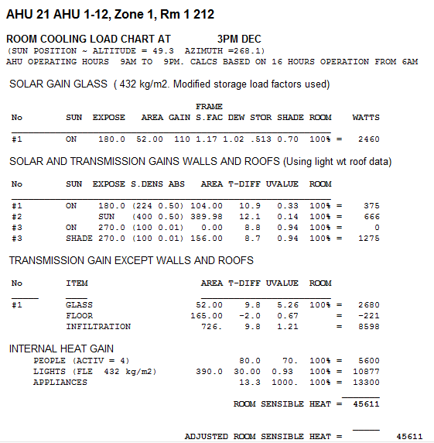

**Figure 45 Cooling Load of 212**

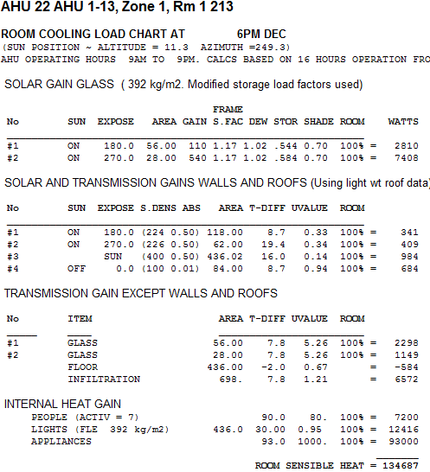

**Figure 46 Cooling Load of 213**

|  |  |  |  |  |  |
| --- | --- | --- | --- | --- | --- |
|  | **212** | **Percentage** | **213** | **Percentage** | **Average percentage** |
| **Appliances** | 13300 | 0.2915963 | 93000 | 0.6904898 | 0.491043064 |
| **Lights** | 10877 | 0.2384732 | 12416 | 0.0921841 | 0.165328638 |
| **People** | 5600 | 0.1227774 | 7200 | 0.0534573 | 0.088117338 |
| **Infiltration** | 8598 | 0.1885072 | 6572 | 0.0487946 | 0.118650886 |
| **Total sensible heat** | 45611 |  | 134687 |  |  |

**Table 13 Percentage of Appliances, Lights, People and Infiltration to Total Sensible Heat**

## 10.2 Reducing Air Off Temperature and Cooling Coil Capacity

Cooling coil capacity is calculated by formula , where is mass flow rate, is specific heat capacity and is temperature difference between outside air and air-off temperature. Reducing air-off temperature (coil temperature) can increase temperature difference, which means cooling coil capacity can be increased in this method.

## 10.3 Improvements to Reduce Required Cooling Capacity

### 10.3.1 Adding Thermal Insulation Materials on External Walls

U-value (thermal transmittance) is used to describe the capacity of material’s heat transmissibility. Materials with a higher U-value have stronger heat transmissibility. Therefore, reducing U-value of external walls by adding thermal insulation materials is a method to reduce required cooling capacity. In CAMEL settings, original wall of 215 south wall is W112 with U-value of . Test U-value is with the same surface density, i.e., as the following figure 47shows. Sensible cooling load with a lower U-value and original sensible cooling load are shown in figure48 and figure 49 below. It is obvious to find that sensible cooling load was reduced from 94652W to 91383W. Reducing U-values by adding thermal insulation materials is valid.

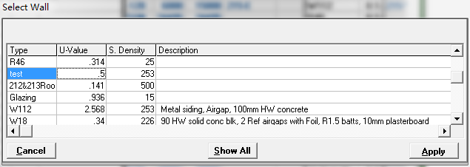

**Figure 47 Settings of Test U-value**

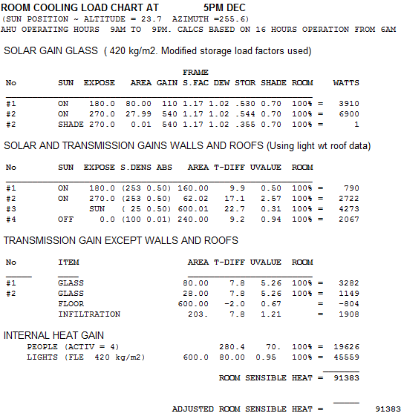

**Figure 48 Sensible Cooling Load of 215 with Test U-value**

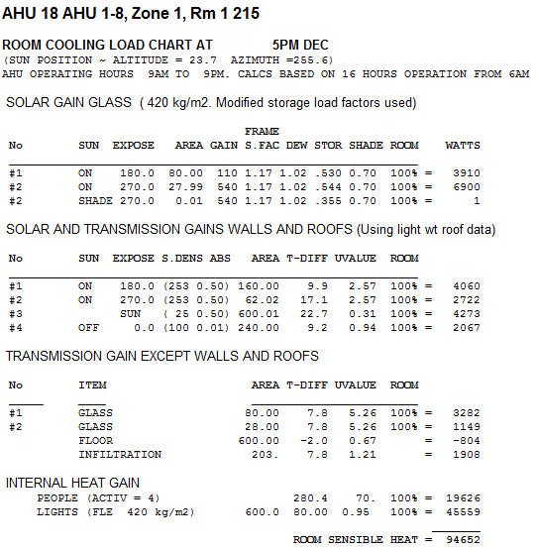

**Figure 49 Original Sensible Cooling Load of 215**

### 10.3.2 Food Court façade

Reduction of ceiling wall and shelter fin degree to 15o can provide more shaded area on ceiling. In this situation, less solar radiation can go through the ceiling façade. The new shading schematic with 15o test degree is demonstrated in figure 50 below. New sensible cooling load is displayed below in the following figure51**.** And original sensible cooling load is demonstrated in figure 52. A conclusion can be easily reached that new shading schematic with 15o between ceiling wall and fin can reduce required cooling load from 119371W to 118295W. This method is proven to be valid.

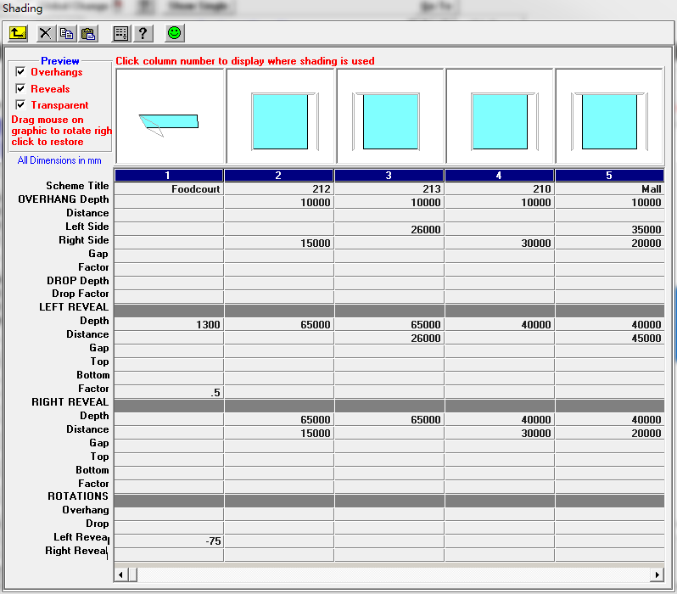

**Figure 50 Settings of Test Shading on Food Court Glazing**

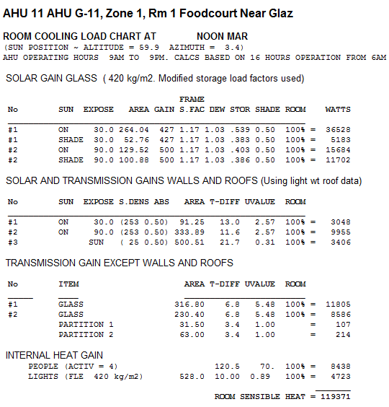

**Figure 51 Sensible Cooling Load of G-11 Food Court with Test Shading Schematic**

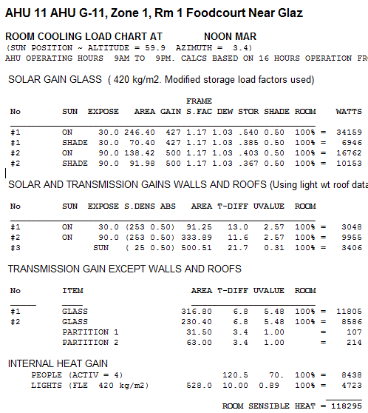

**Figure 52 Original Sensible Cooling Load of G-11 Food Court**

### 10.3.3 Shading on Windows

Adding shading on windows can decrease sun radiation through windows. In this way, required cooling load can be reduced. As figure 53 shows below, shading is installed over the 215 west windows. Camel simulation result is demonstrated in figure 54 below. Total sensible heat load is 93007W, which is smaller than the original heat load 94652W shown in figure 52 above. Hence, this is proven to be valid.

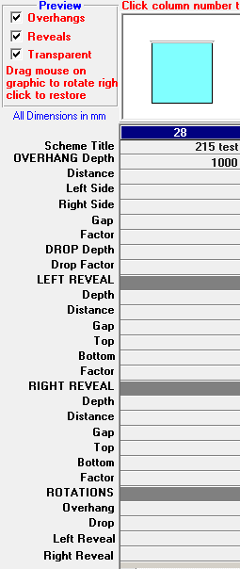

**Figure 53 Test Shading schematic on 215 east windows**

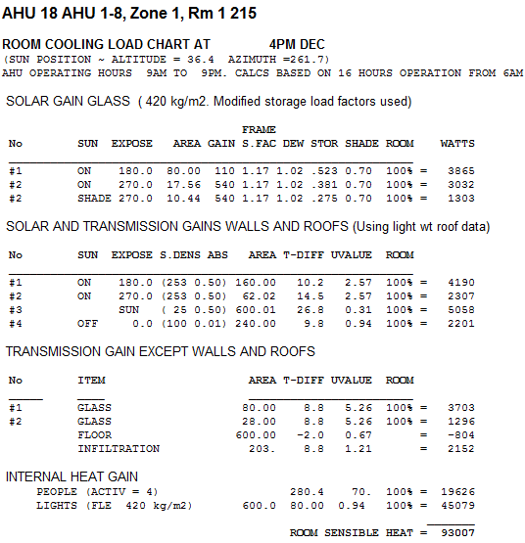

**Figure 54 Sensible Cooling Load of 215 with Test Windows Shading**

# 11 Conclusion

This report aims to provide simulation for part A hand calculation. In section 1, air-conditioned spaces and ventilated spaces are divided apart. In section 3, Camel is used to simulate heat load for the whole building especially for rooms 212 and 213. In section 4, Camel simulation outcome is compared with hand calculation result. The difference between simulation and hand calculation is lower than 8%. In section 5, air schematics are drawn by using seven risers. In section 6, all ducts are sorted into thirteen types with its own maximum flow rate and rectangular dimensions. In section 8, AHU is selected by two criteria: air flow rate and power. In section 2 and section 7, exhaust air flow rate of mechanically ventilated spaces is calculated and pressure loss for ventilated areas are calculated as well. Relative fans are selected by three factors: noise, pressure loss and efficiency. In section 9, improvements and suggestions on required cooling capacity are made.

# References

1. **MECH4880 Refrigeration and Air Conditioning ASSIGNMENT 1 (2016) - Project Specifications**
2. **MECH4880 Refrigeration and Air Conditioning Assignment 1 (2016) – Part A and Part B Overview**
3. **Part 4: Natural ventilation of buildings, The use of ventilation and airconditioning in buildings, Australian Standard 1668.4 – 2012**
4. **Part 2: Mechanical ventilation in buildings, The use of ventilation and airconditioning in buildings, Australian Standard 1668.2 – 2012**
5. **Assignment 1 (2016) – Amendment – Rev 3**

# Appendix 1 Camel Simulation Outcome

**AHU 21 AHU 1-12, Zone 1, Rm 1 212**

**ROOM COOLING LOAD CHART AT 3PM DEC**

(SUN POSITION ~ ALTITUDE = 49.3 AZIMUTH =268.1)

AHU OPERATING HOURS 9AM TO 9PM. CALCS BASED ON 16 HOURS OPERATION FROM 6AM

SOLAR GAIN GLASS ( 432 kg/m2. Modified storage load factors used)

**FRAME**

**No SUN EXPOSE AREA GAIN S.FAC DEW STOR SHADE ROOM WATTS**

_______________________________________________________________________________

#1 ON 180.0 52.00 110 1.17 1.02 .513 0.70 100% = 2460

SOLAR AND TRANSMISSION GAINS WALLS AND ROOFS (Using light wt roof data)

**No SUN EXPOSE S.DENS ABS AREA T-DIFF UVALUE ROOM**

_______________________________________________________________________________

#1 ON 180.0 (224 0.50) 104.00 10.9 0.33 100% = 375

#2 SUN (400 0.50) 389.98 12.1 0.14 100% = 666

#3 ON 270.0 (100 0.01) 0.00 8.8 0.94 100% = 0

#3 SHADE 270.0 (100 0.01) 156.00 8.7 0.94 100% = 1275

TRANSMISSION GAIN EXCEPT WALLS AND ROOFS

**No ITEM AREA T-DIFF UVALUE ROOM**

_______________________________________________________________________________

#1 GLASS 52.00 9.8 5.26 100% = 2680

FLOOR 165.00 -2.0 0.67 = -221

INFILTRATION 726. 9.8 1.21 = 8598

INTERNAL HEAT GAIN

PEOPLE (ACTIV = 4) 80.0 70. 100% = 5600

LIGHTS (FLE 432 kg/m2) 390.0 30.00 0.93 100% = 10877

APPLIANCES 13.3 1000. 100% = 13300

__________________

**ROOM SENSIBLE HEAT = 45611**

________________

**ADJUSTED ROOM SENSIBLE HEAT = 45611**

LATENT HEAT GAIN

INFILTRATION 726 2.8 2.96 = 6064

PEOPLE (ACTIV = 4) 80.0 60. 100% = 4800

APPLIANCES 3.4 1000. 100% = 3400

________________

**ROOM LATENT HEAT = 14264**

________________

**ADJUSTED ROOM LATENT HEAT = 14264**

**AHU 22 AHU 1-13, Zone 1, Rm 1 213**

**ROOM COOLING LOAD CHART AT 6PM DEC**

(SUN POSITION ~ ALTITUDE = 11.3 AZIMUTH =249.3)

AHU OPERATING HOURS 9AM TO 9PM. CALCS BASED ON 16 HOURS OPERATION FROM 6AM

SOLAR GAIN GLASS ( 392 kg/m2. Modified storage load factors used)

**FRAME**

**No SUN EXPOSE AREA GAIN S.FAC DEW STOR SHADE ROOM WATTS**

_______________________________________________________________________________

#1 ON 180.0 56.00 110 1.17 1.02 .544 0.70 100% = 2810

#2 ON 270.0 28.00 540 1.17 1.02 .584 0.70 100% = 7408

SOLAR AND TRANSMISSION GAINS WALLS AND ROOFS (Using light wt roof data)

**No SUN EXPOSE S.DENS ABS AREA T-DIFF UVALUE ROOM**

_______________________________________________________________________________

#1 ON 180.0 (224 0.50) 118.00 8.7 0.33 100% = 341

#2 ON 270.0 (226 0.50) 62.00 19.4 0.34 100% = 409

#3 SUN (400 0.50) 436.02 16.0 0.14 100% = 984

#4 OFF 0.0 (100 0.01) 84.00 8.7 0.94 100% = 684

TRANSMISSION GAIN EXCEPT WALLS AND ROOFS

**No ITEM AREA T-DIFF UVALUE ROOM**

_______________________________________________________________________________

#1 GLASS 56.00 7.8 5.26 100% = 2298

#2 GLASS 28.00 7.8 5.26 100% = 1149

FLOOR 436.00 -2.0 0.67 = -584

INFILTRATION 698. 7.8 1.21 = 6572

INTERNAL HEAT GAIN

PEOPLE (ACTIV = 7) 90.0 80. 100% = 7200

LIGHTS (FLE 392 kg/m2) 436.0 30.00 0.95 100% = 12416

APPLIANCES 93.0 1000. 100% = 93000

__________________

**ROOM SENSIBLE HEAT = 134687**

________________

**ADJUSTED ROOM SENSIBLE HEAT = 134687**

LATENT HEAT GAIN

INFILTRATION 698 3.4 2.96 = 7073

PEOPLE (ACTIV = 7) 90.0 80. 100% = 7200

APPLIANCES 23.9 1000. 100% = 23900

________________

**ROOM LATENT HEAT = 38173**

________________

**ADJUSTED ROOM LATENT HEAT = 38173**

# Appendix 2 Ductulator Result of Duct Sizes

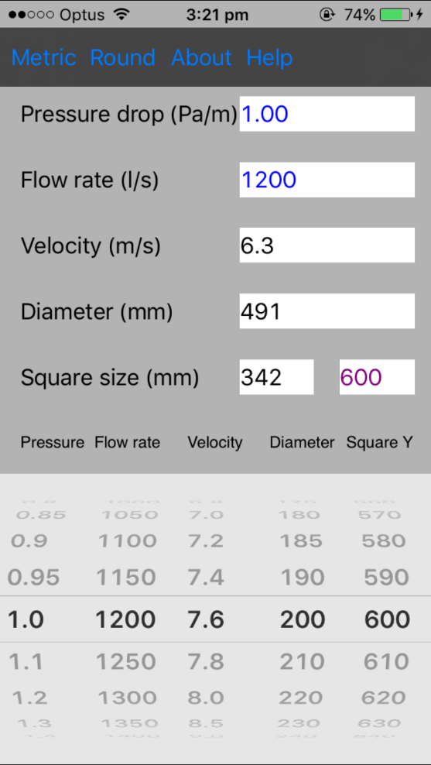 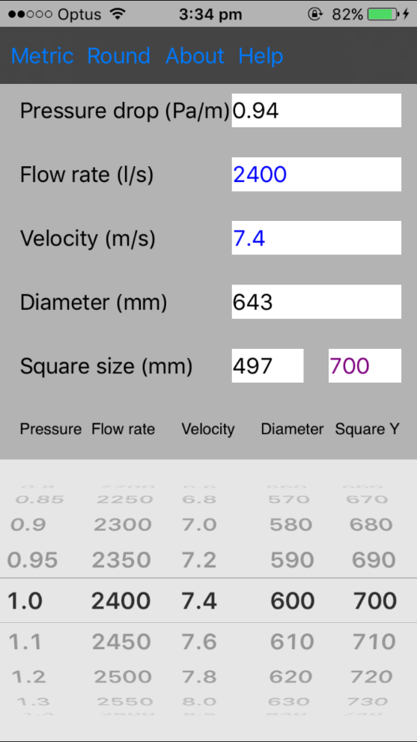

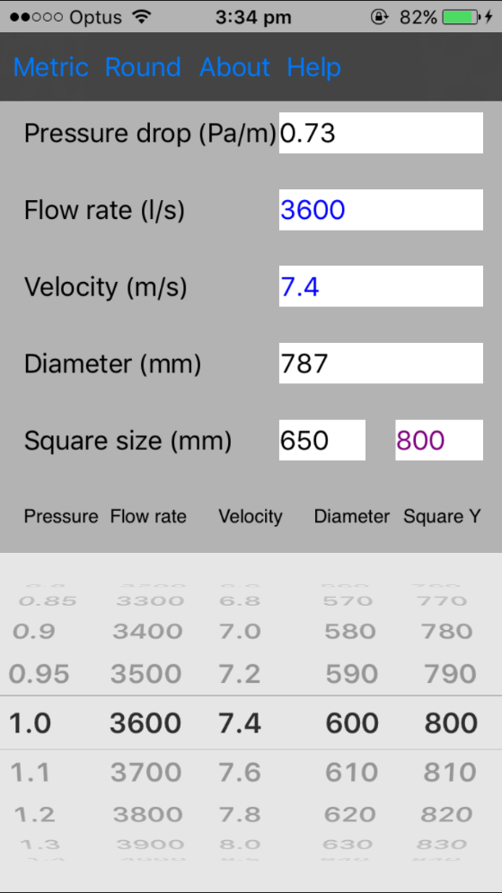 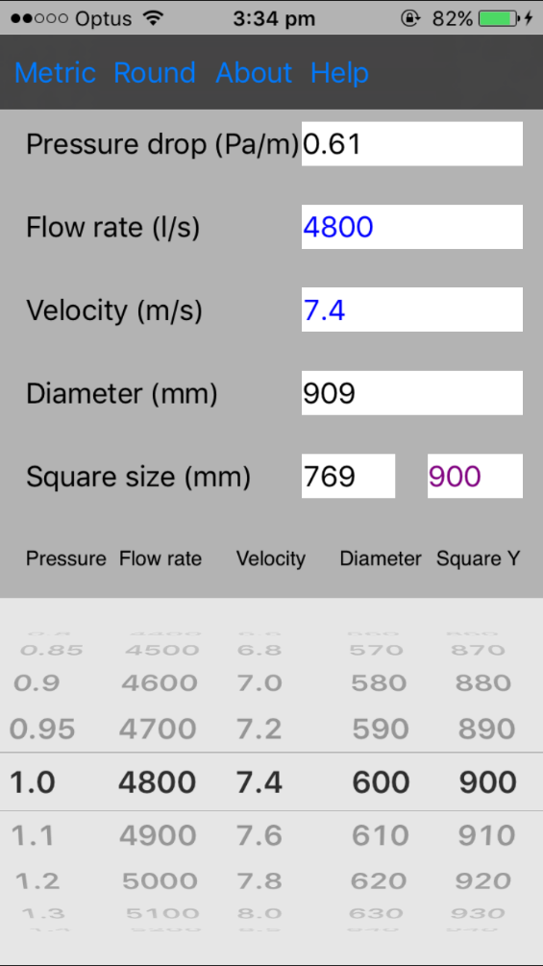

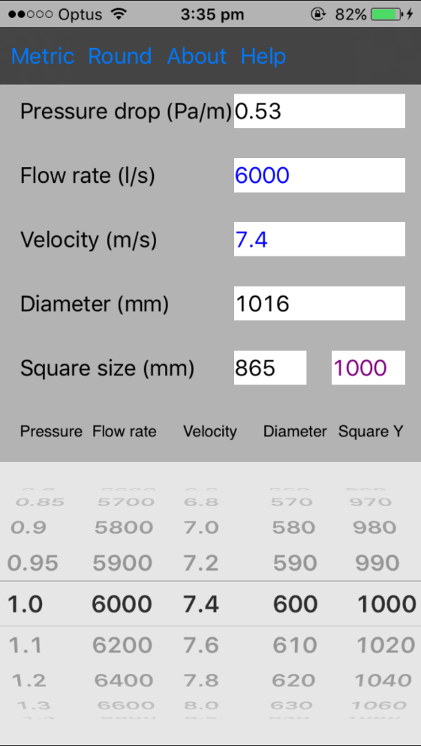 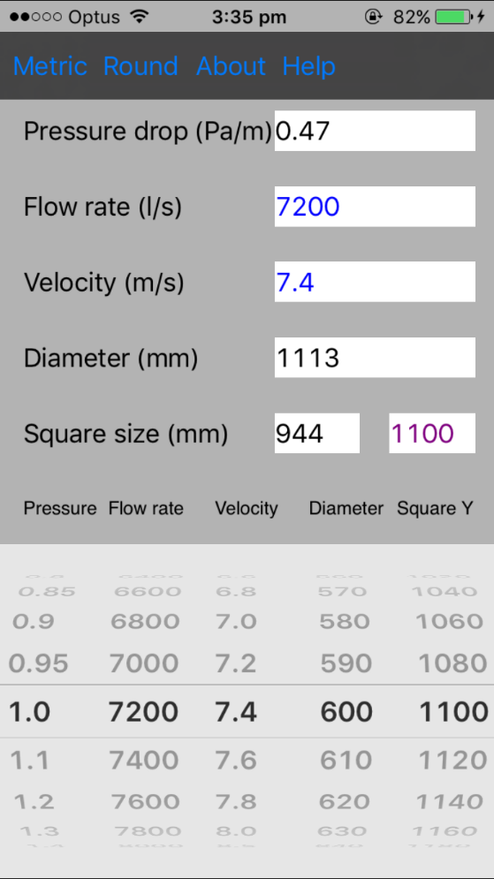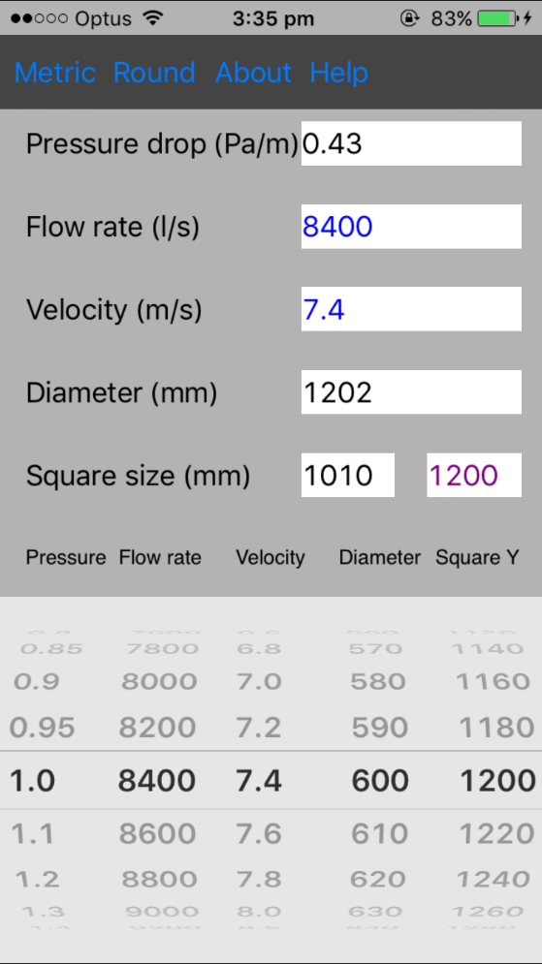 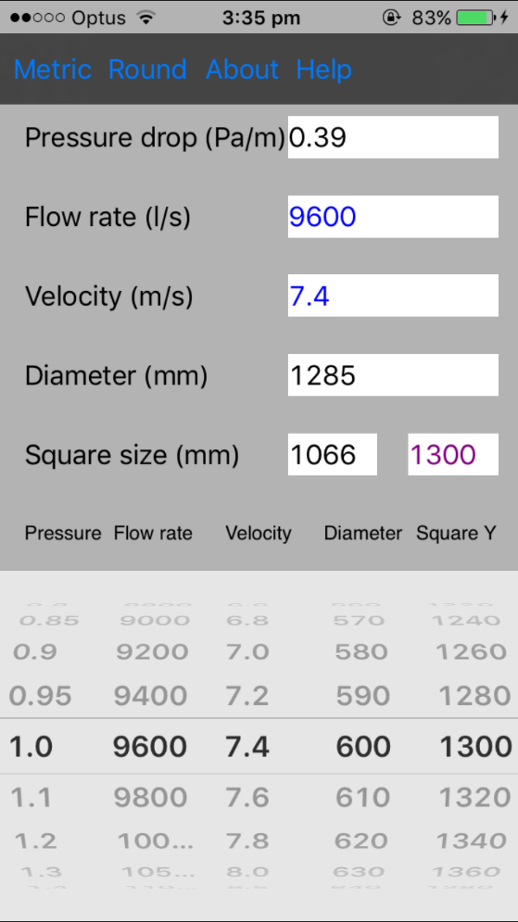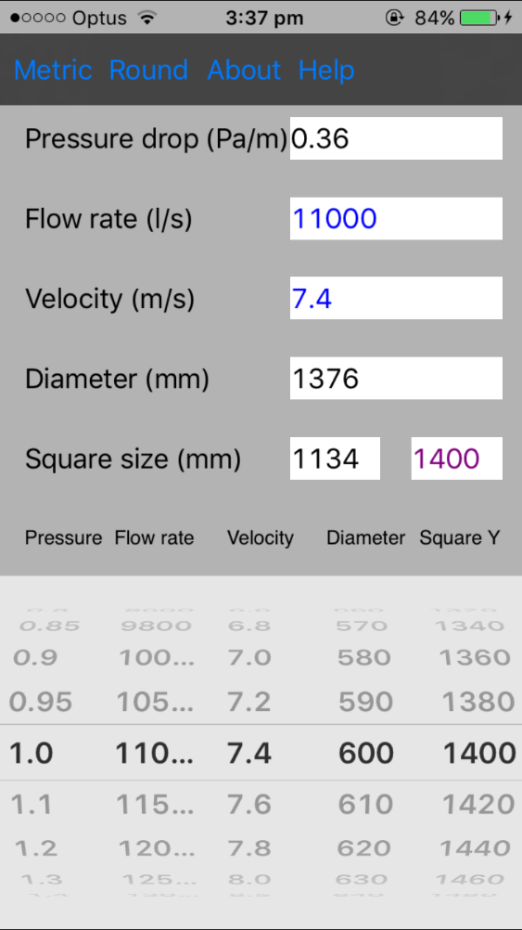 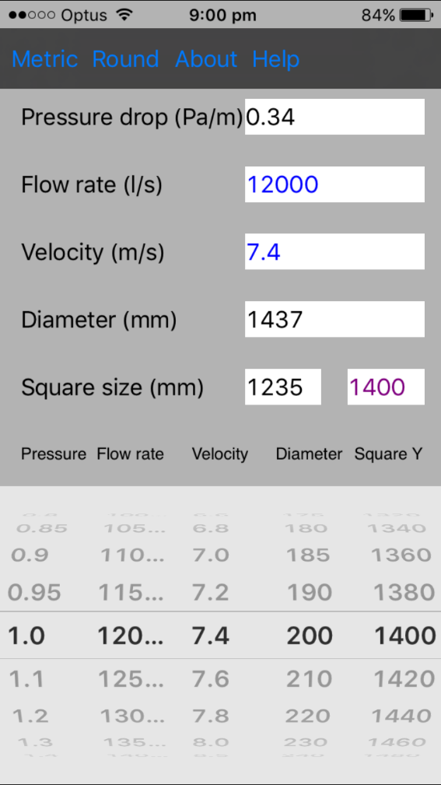

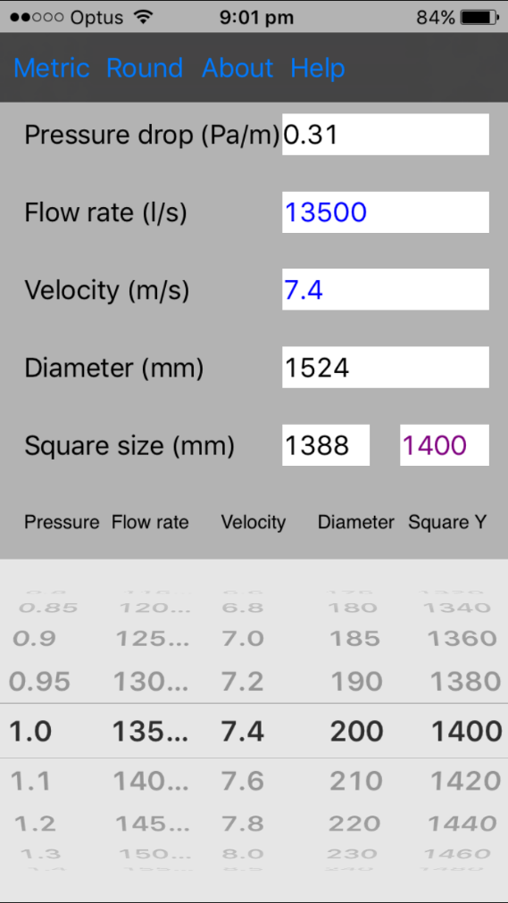 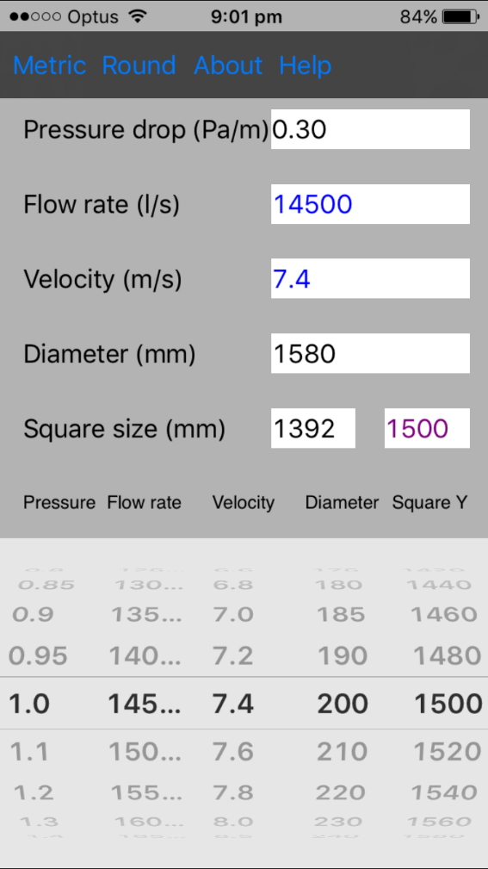

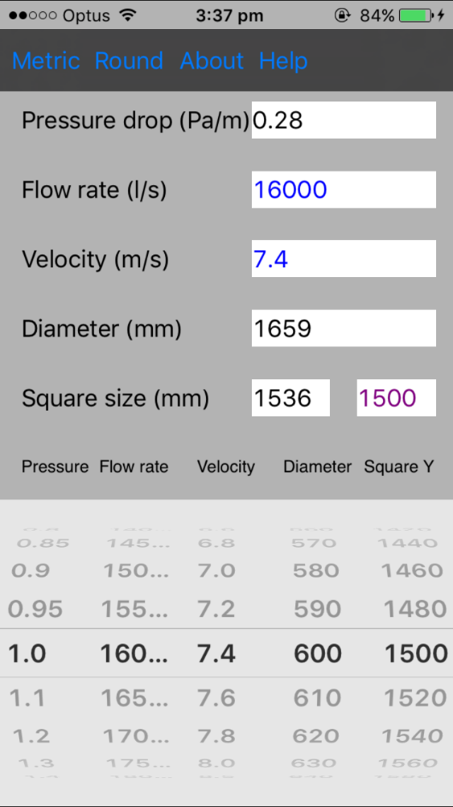

# Appendix 3 Detailed Duct Design of Ground Floor and First Floor

Detailed ground floor duct design layout can be found in the following figures.  
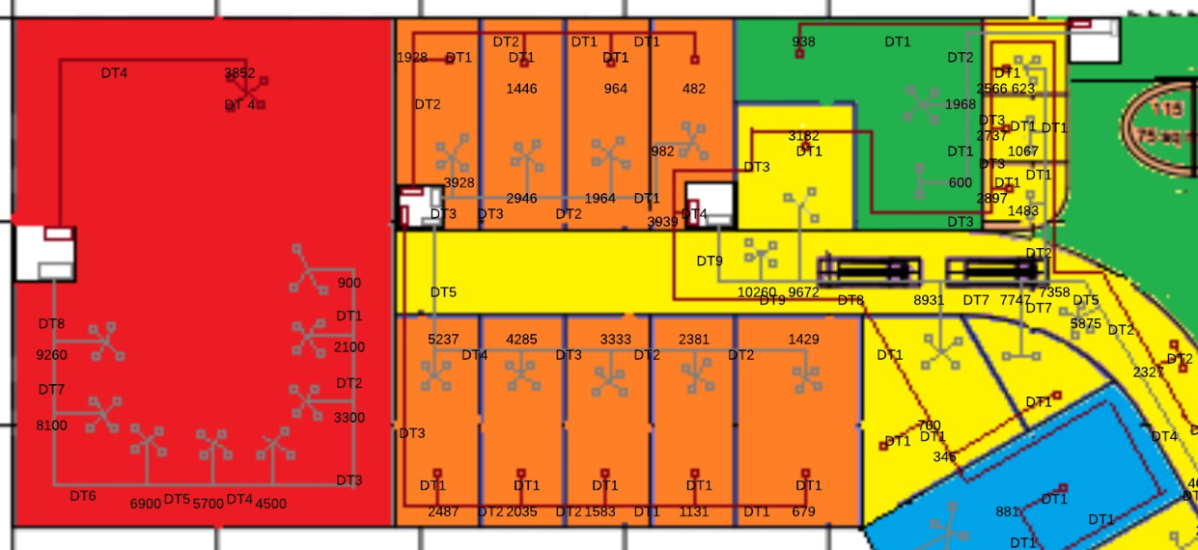

West Part

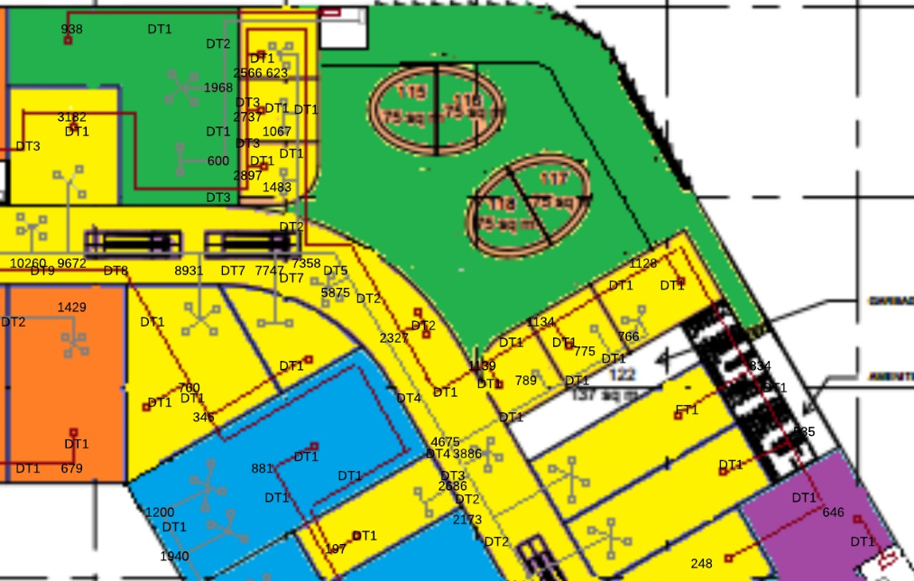

1. Middle part

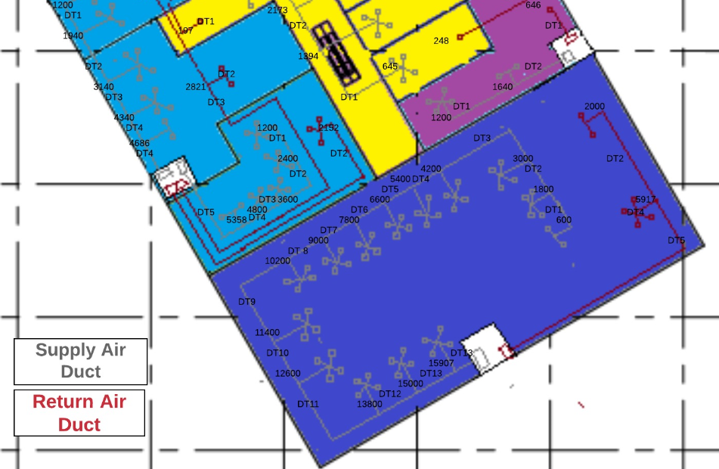

1. East part

**Figure Detailed Duct Design of First Floor**

Detailed first floor duct design layout can be found in the following figures.

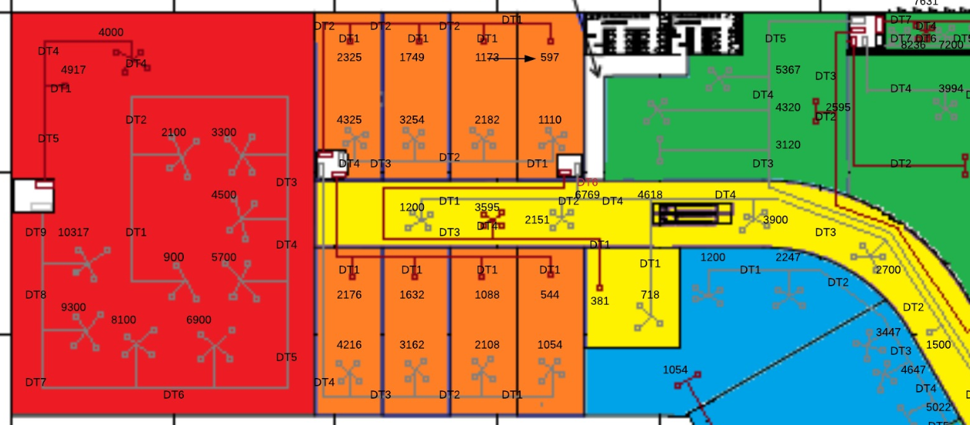

1. West Part

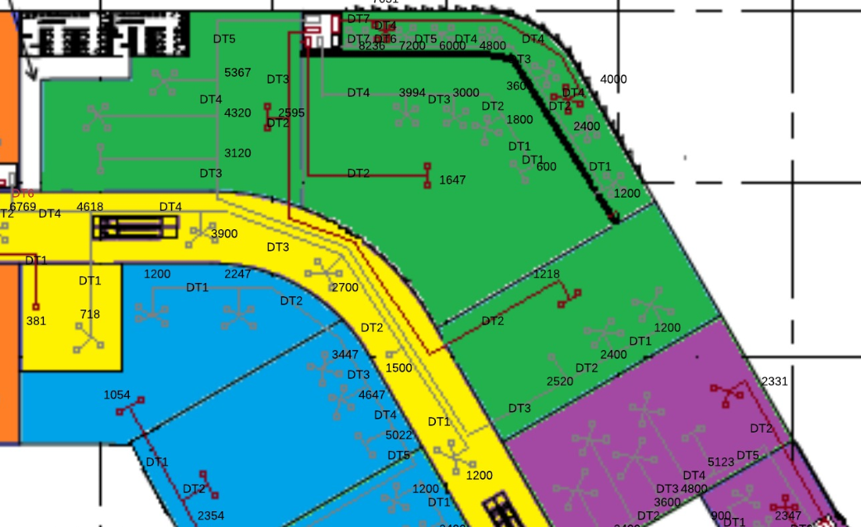

1. Middle Part 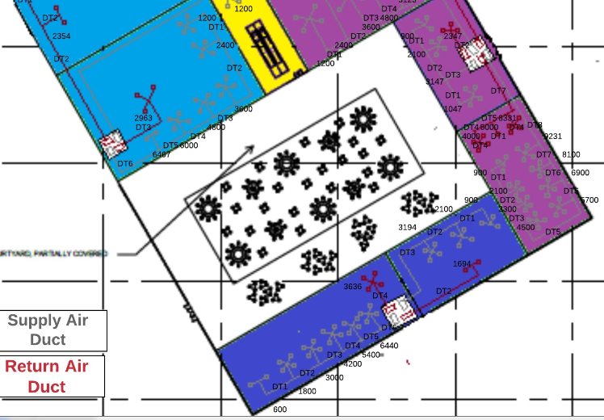
2. West Part